DAYANAND COLLEGE OF LAW, LATUR
NATIONAL SERVICE SCHEME
ANNUAL REPORT 2025-26

To foster the roots of service to society, labour, national integrity, positive attitude, social responsibility and to create awareness regarding superstitions, dowry system, sex discrimination, environmental pollution, water conservation and the like in our students and the members in the society, the NSS Volunteers always struggle.
Annual Report –
For the Academic Year 2025-26, 100 students were admitted as volunteers of NSS. A meeting was called for under the guidance of the Principal Dr. Poonam Nathani.
On the basis of marks and interview conducted, Mr. Ajinkya Waghmare, one of the volunteers was selected as NSS Representative for the year 2025-26.
In the academic year 2025-2026, various programmes were organized by our NSS unit which include the following -

- Vasantrao Naik Birth Anniversary (Agriculture Day) (Date - 01.07.2025) -
The NSS Unit of Dayanand College of Law, Latur celebrated Birth Anniversary of Former Chief Minister of State of Maharashtra Late Vasantrao Naik as "Agriculture Day" on 01.07.2025.
This Day is celebrated in the remembrance of the Father of Green Revolution of Maharashtra - Vasantrao Naik. He was an Indian politician, who served as Chief Minister of Maharashtra during 1963-1975. He remains as the longest serving CM of Maharashtra.
At the outset, Dr. Poonam Nathani, Principal offered garland to the image of Late Vasantrao Naik. The teaching, non-teaching staff and students also paid him the homage. Later, the Programme Officer provided the information dealing with childhood, education, advocacy, social service, works as politician and Chief Minister of State of Maharashtra. He also provided that, Late Vasantrao Naik is prominently known as Father of Green Revolution, White Revolution, EGS, Cotton Monopoly Scheme, Law of Land Ceiling, establishment of MAHABEEJ, Crop Insurance Scheme, recognition to Leader of Opposition as Cabinet Minister, and many more. During his reign, several Agricultural Universities and institutions were established in the State which significantly helped agriculture to grow and prosper.
This Day also marks to honour the immense contribution of the farmers in the agriculture sector and national progress.
Dr. Poonam Nathani, Principal, Teaching and Non- Teaching Staff, students and Asst Prof. Umesh Katekar, Programme Officer were present at this programme.

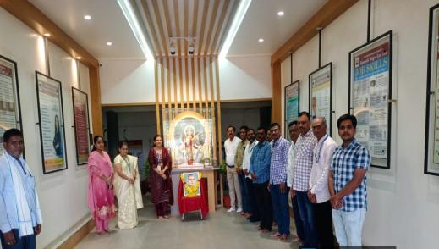
Celebration of Birth Anniversary of Father of Green Revolution in the State of Maharashtra Late Shri. Vasantrao Naik at Dayanand College of Law, Latur
(Date -01.07.2025)
- Celebration of Birth Anniversary of Lokmanya Tilak (Date - 23.07.2025) -
On 23.07.2025, NSS, Dayanand College of Law, Latur arranged a programme to celebrate the Birth Anniversary of Lokmanya Bal Gangadhar Tilak who is known as the “Father of Indian Unrest”.
At the outset, respected Mrs. Kalyani Pande Madam, Presiding Officer, School Tribunal, Latur and Dr. Poonam Nathani, Principal offered the chaplet to the image of Lokmanya Tilak. The participants also paid homage to Lokmanya.
Later, Mr. Ganesh Ijare, NSS Volunteer shared the information on the life story of Lokmanya which included his childhood, primary and higher education, entry into the national struggle, works in the fields like social and political service, freedom fighting, ideologies, literature and the like. He also provided that, Lokmanya was one of the greatest freedom fighters, extremist, writer and social worker from the State of Maharashtra.
The Teaching and Non-Teaching Members, students and Programme Officer were actively present in this programme. This programme was anchored by Miss. Kirti Pande and vote of thanks was proposed by Miss. Rutuja Deshmukh, NSS Volunteers.

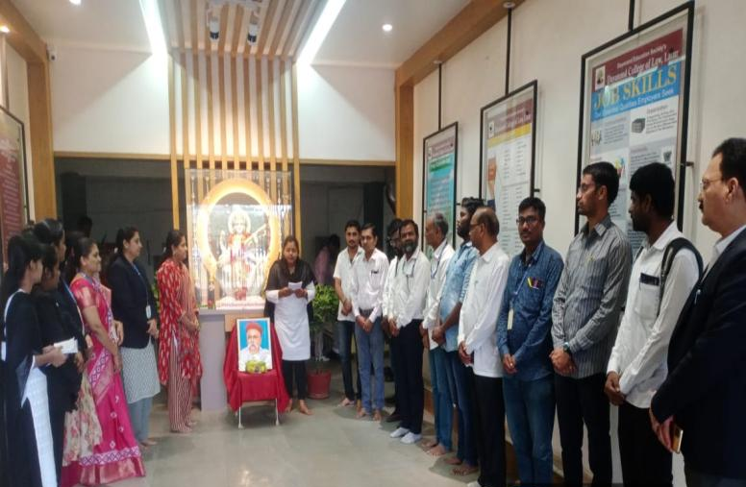
Celebration of Birth Anniversary of Lokmanya Tilak (Date - 23.07.2025)

- Birth Anniversary of Annabhau Sathe (Date - 01.08.2025) -
Today, NSS, Dayanand College of Law, Latur arranged a programme to celebrate the birth anniversary of Lokshahir Annabhau Sathe, a social reformer, folk artist, and great writer from the State of Maharashtra.
At the outset, Dr. Poonam Nathani, Principal of the College offered garland to the image of and paid homage to Lokshahir Annabhau Sathe which was followed by the participants.
Later, Miss Vaishnavi Panchal, NSS Volunteer shared the valuable information about the childhood of Annabhau, his education, socio-political works, literature, philosophy, contribution in the field of upliftment of poor and labour class of the society, etc.
The Teaching and Non-Teaching Members, students and Programme Officer Asst. Prof. Umesh Katekar were actively present in this programme. This programme was anchored and vote of thanks were proposed by Miss Rajashree Kale and Miss Deepali Kendre respectively.

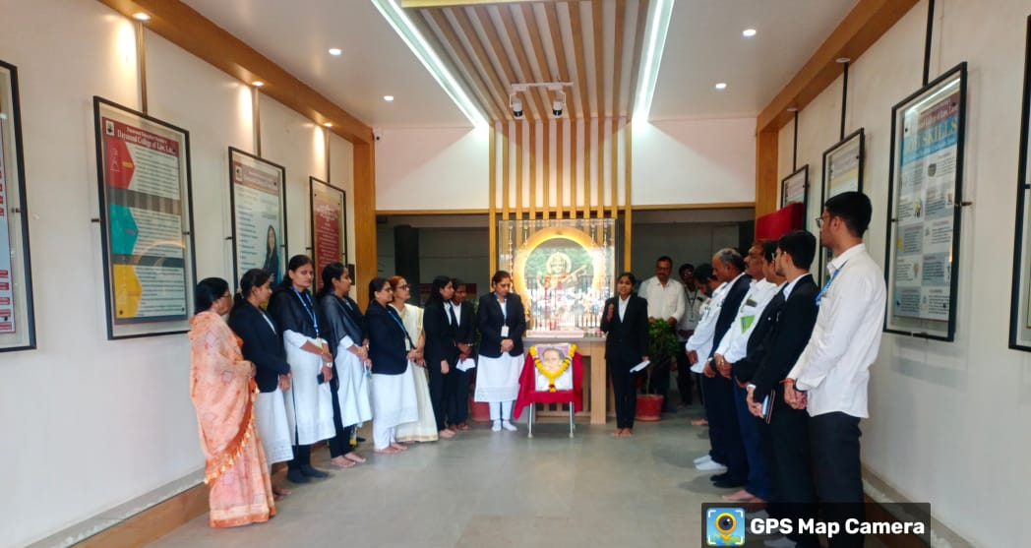
Celebration of Birth Anniversary of Lokshahir Annabhau Sathe (Date - 01.08.2025)

- Elocution Competition (Date - 14.08.2025) -
Today, NSS Unit, Dayanand College of Law, Latur organized an “Elocution Competition” in the College on the significant and contemporary topics of Environmental Protection, Gender Equality and Indian Democracy. The objective for organizing this Competition was to enhance student’s public speaking skills and confidence and also to encourage them to express their views on the relevant topics.
The participant students from various classes of the College presented speeches on the given topics as per their choice, displaying their oratory skills and ability to articulate their thoughts effectively. The competition followed a structured format, with judges evaluating speeches based on content, delivery, and overall impact. The event concluded with the announcement of winners by the Judges and vote of thanks, highlighting the success of the Competition in fostering a platform for students to express themselves. Dr. Manisha Ashtekar, Associate Professor and HOD of Commerce Department, Dayanand College of Commerce and Dr. Gopal Lohiya, Department of Pharmaceutical Quality assurance at Dayanand College of Pharmacy, Latur, graced the occasion as judges.
The event was a success, providing a platform for students to enhance their public speaking skills and boost their confidence. 19 students took active participation in this Competition. This Competition was conducted under the guidance of Dr. Poonam Nathani, Principal. Volunteers and Programme Officer, NSS took efforts to make this programme successful one.

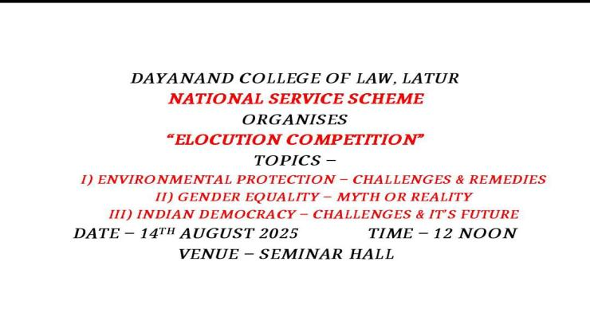
Flyer of the Elocution Competition
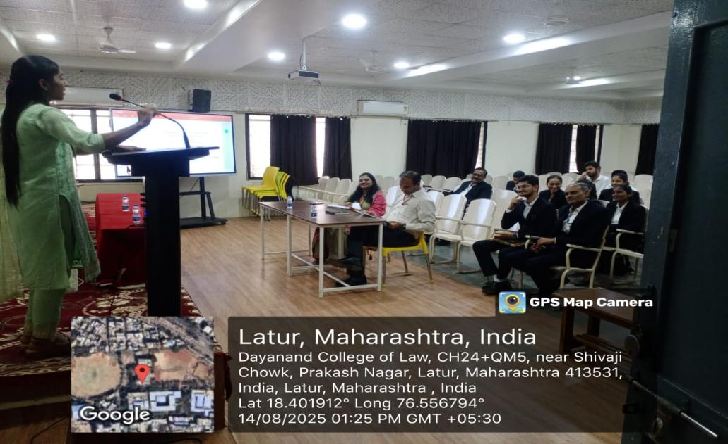

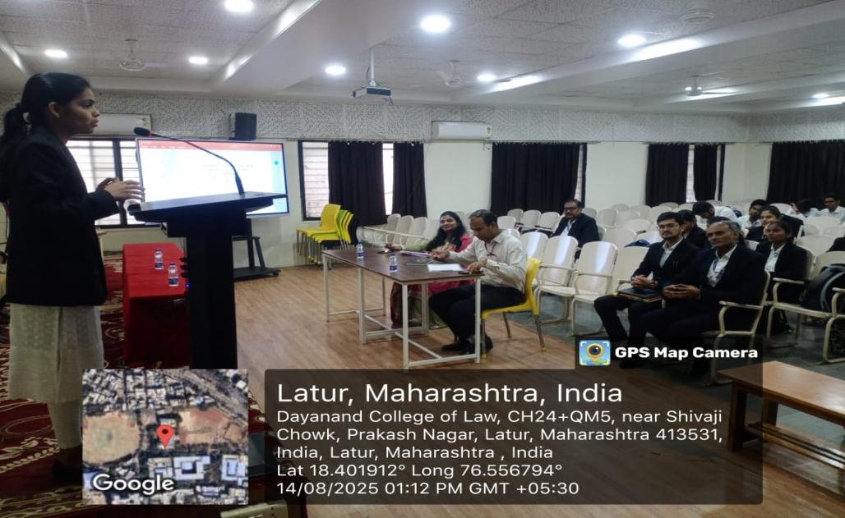

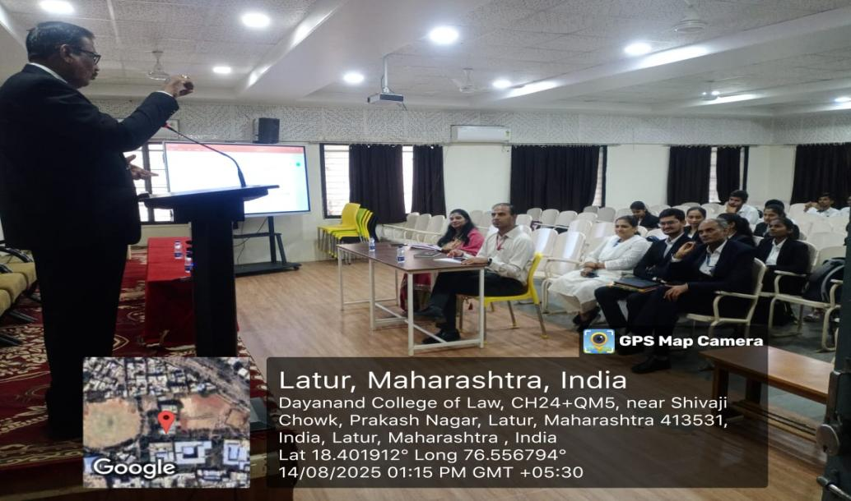

The participants performing during the Elocution Competition (Date - 14.08.2025)

- Birth Anniversary of Rajiv Gandhi (Sadbhavana Din) (Date - 20.08.2025) -
On 20.08.2025, NSS Unit celebrated birth anniversary of former Prime Minister of India Late Rajiv Gandhi as "Rashtriya Sadbhavana Din" i.e. ‘National Harmony Day’.
At this occasion, at the outset, Dr. Poonam Nathani, Principal offered the chaplet & flowers to the image of Rajivji. Asst. Prof. Meghmala Kamble, then, shared the information regarding the work-life history of Rajivji, his works in the areas of science, technology, human resources and education. She also added more information about Rajivji's work in spreading the spirit of harmony and brotherhood among all the citizens irrespective of their religion, caste or creed. Later, the "National Harmony Pledge" was administered to all the participants. This programme was anchored and vote of thanks were proposed by the Programme Officer Asst. Prof. Umesh Katekar.
Dr. Poonam Nathani, I/C Principal, Teaching and Non-Teaching Staff, students and Asst. Prof. Umesh Katekar, Programme Officer, NSS were present at this occasion.

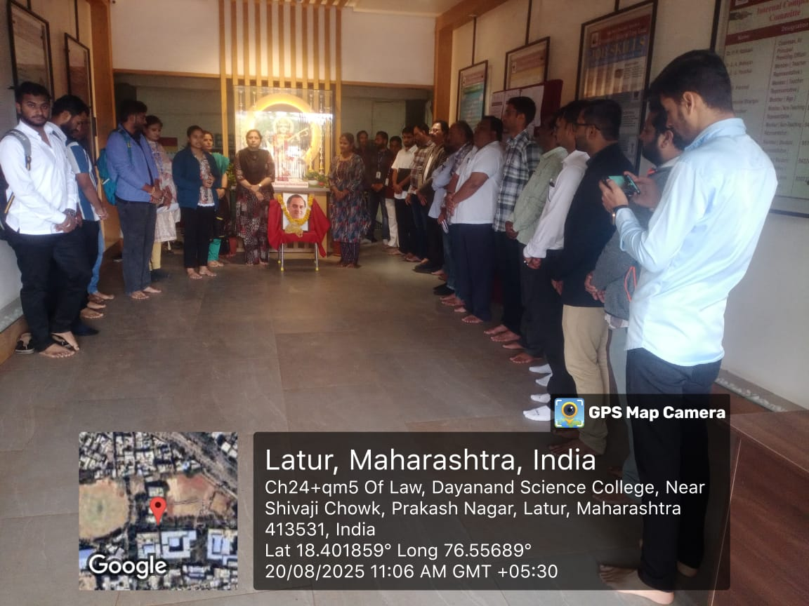

Celebration of birth anniversary of Rajivji Gandhi as Sadbhavana Din
(Date - 20.08.2025).

- Mahatma Gandhi & Lal Bahadur Shastri Jayanti (Date - 02.10.2025) -
On 02.10.2025, NSS, Dayanand College of Law, Latur arranged a programme to celebrate the birth anniversaries of Mahatma Gandhi, National Father & Lal Bahadur Shastri, Former Prime Minister of India.
At the outset, Dr. Shubhangi Panchal, I/C Principal of the College offered garlands to the images of and paid homage to Mahatma Gandhi & Lal Bahadur Shastri. The participants also paid homage to the great leaders and national heroes of India.
Later, Miss Rajashri Kale, one of the students shared the valuable information about the childhood of Mahatma Gandhi, his education, socio-political works, literature, philosophy, and his contribution in national struggle of freedom, etc.
Asst. Prof. Atish Tiwari also gave information on the lifeworks of Lal Bahadur Shastri focusing on his childhood, education, his commendable works as Railway Minister and the Second Prime Minister of India, his works in the progression of White and Green Revolution, etc.
The Teaching and Non-Teaching Members, students and Asst. Prof. Umesh Katekar, Programme Officer, NSS were actively present in this programme. This programme was anchored by Miss Deepali and vote of thanks was proposed by the Programme Officer.

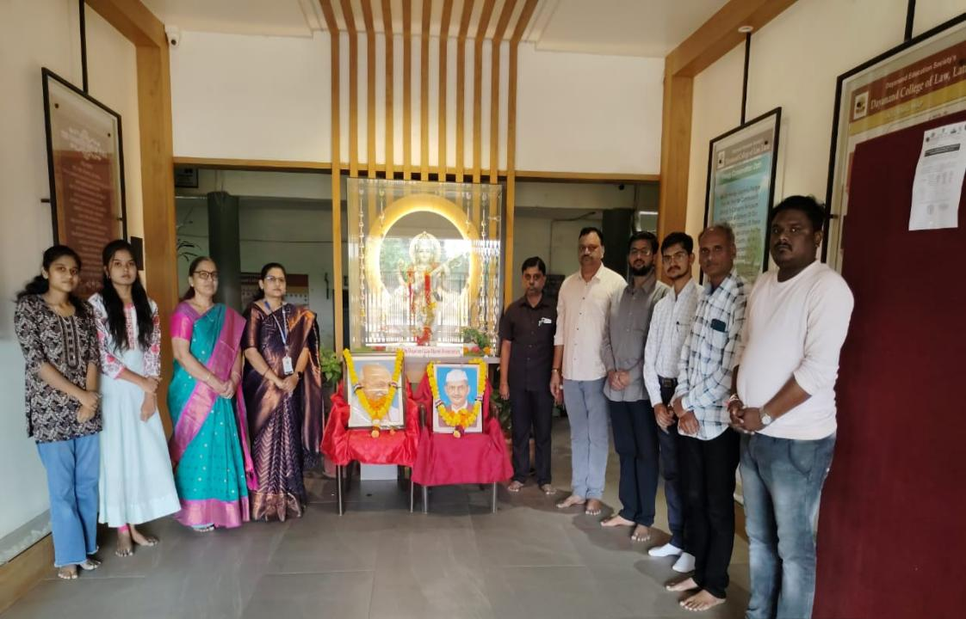

Celebration of Birth Anniversaries of Mahatma Gandhi and Lal Bahadur Shastri at Dayanand College of Law, Latur (Date - 02.10.2025).

- Quiz on Energy Conservation & Environment Protection (Date - 11.10.2025) -
The Green & Energy Club of Dayanand College of Law, Latur organized a Quiz Competition on the topic of “Energy Conservation & Environmental Protection” on 11th October 2025. The objective of this Quiz Competition is to spread awareness regarding energy conservation and environmental protection.
In the beginning, Energy Conservation Pledge’ was given to all the participants. Dr. Atul Deulgaonkar, renowned environmentalist and philanthropist of Latur, Dr. Poonam Nathani, Principal, all the staff members and students enthusiastically took the pledge.
Later, about 87 students participated in this Quiz Competition. The winners of this Competition were awarded with cash prizes.
Prof. Gopal Panchal, Asst. Prof. Shital Ghute, Asst. Prof. Atish Tiwari and Asst. Prof. Umesh Katekar, Programme Officers took efforts to carry out this Competition successfully.
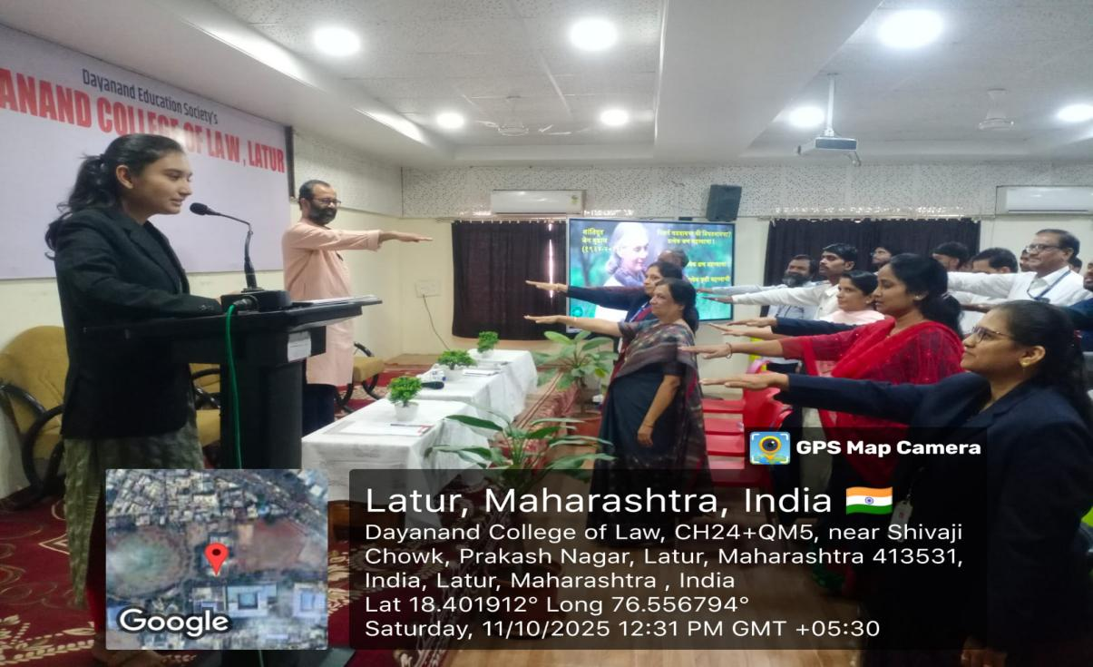

Shri. Atul Deulgaonkar, Dr. Poonam Nathani, Principal, staff and students taking ‘Energy Conservation Pledge’ during the programme (Date - 11.10.2025).

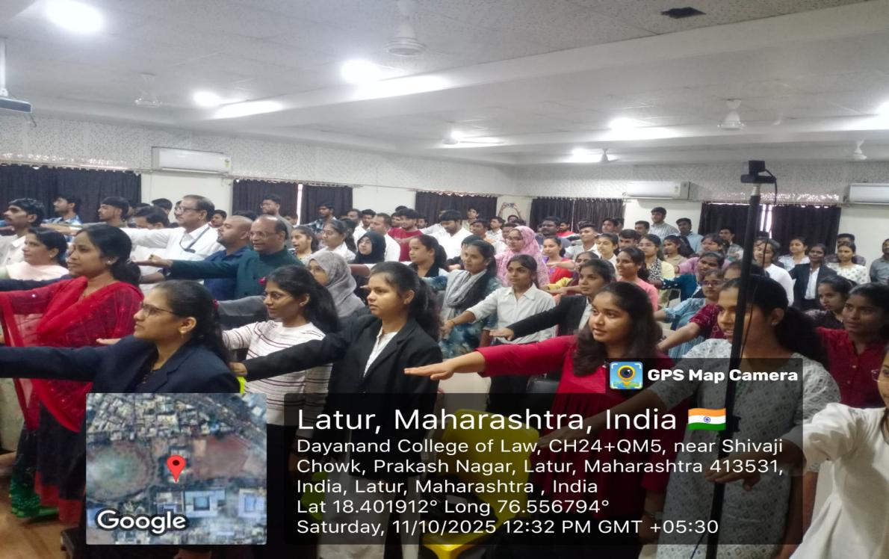

The Staff and students taking the ‘Energy Conservation Pledge’ during the programme (Date - 11.10.2025).
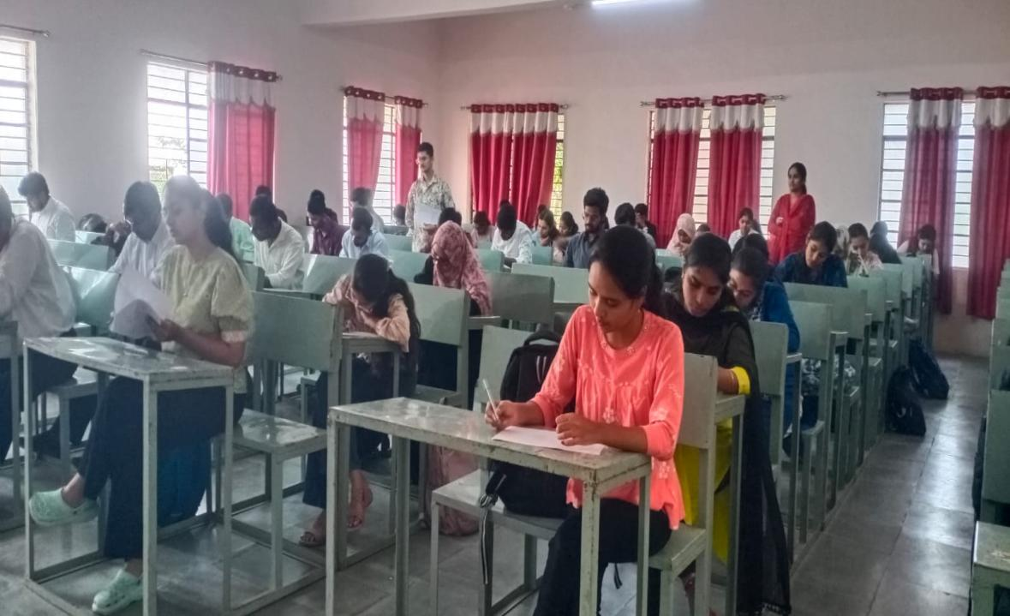

Asst. Prof. Shital Ghute and Asst. Prof. Atish Tiwari conducting the Quiz Competition on ‘Energy Conservation and Environment Protection’(Date - 11.10.2025).

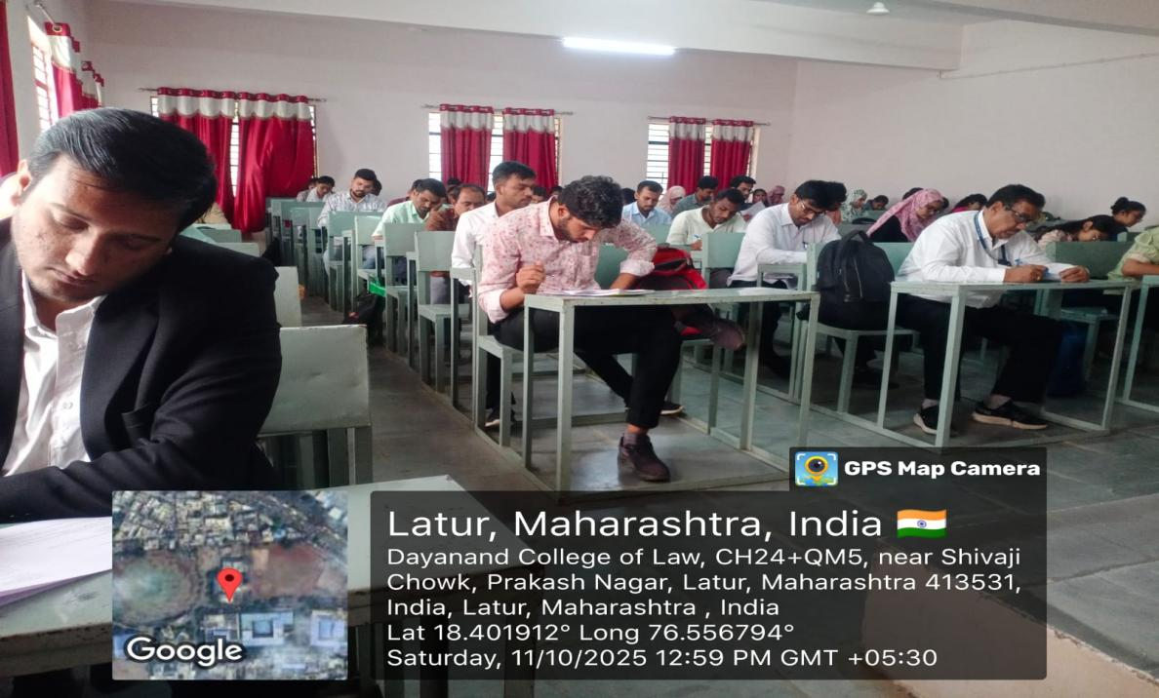

The students attempting the Quiz Competition on ‘Energy Conservation and Environment Protection’(Date - 11.10.2025).

- Celebration of Vachan Prerana Din (Date - 15.10.2025) -
The NSS Department of Dayanand College of Law, Latur organized a Programme on ‘Vachan Prerna Din’ to celebrate the birth anniversary of former President Late Dr. Abdul Qalam, the ‘Missile Man of India’ as ‘Reading Awareness Day’, on 15.10.2025.
Shri. Bharatji Satpute, a renowned author, poet, and philanthropist of Latur was invited to grace the occasion as Resource Person.
At the outset, Shri. Satpute Sir and Dr. Poonam Nathani, Principal offered garland to the image of Qalam Sir. Then, the Principal welcomed the guest and stated the object for the celebration of this day as to pay homage to the former President and a great scientist of India and also to spread awareness regarding reading habits with its significance.
Shri. Satpute Sir during his guidance shared the information regarding the lifeworks of Qalam Sir stating his immense contribution as a scientific genius in the elevation of our nation's prowess in science, defence and technological innovations to unprecedented heights with his unwavering patriotism and the principle of India First.
Later, Shri. Satpute Sir also provided his thoughts about reading habits, its importance for personal growth, social development, and lifelong learning. He also shared his own relevant life experiences.
This programme was anchored by Asst. Prof. Umesh Katekar, Programme Officer, NSS & vote of thanks was proposed by Dr. Sangita Mahajan, Librarian. Asst. Prof. Atish Tiwari, Asst. Programme Officer took efforts to make this programme successful. The faculty members, volunteers, and students actively participated in this programme.
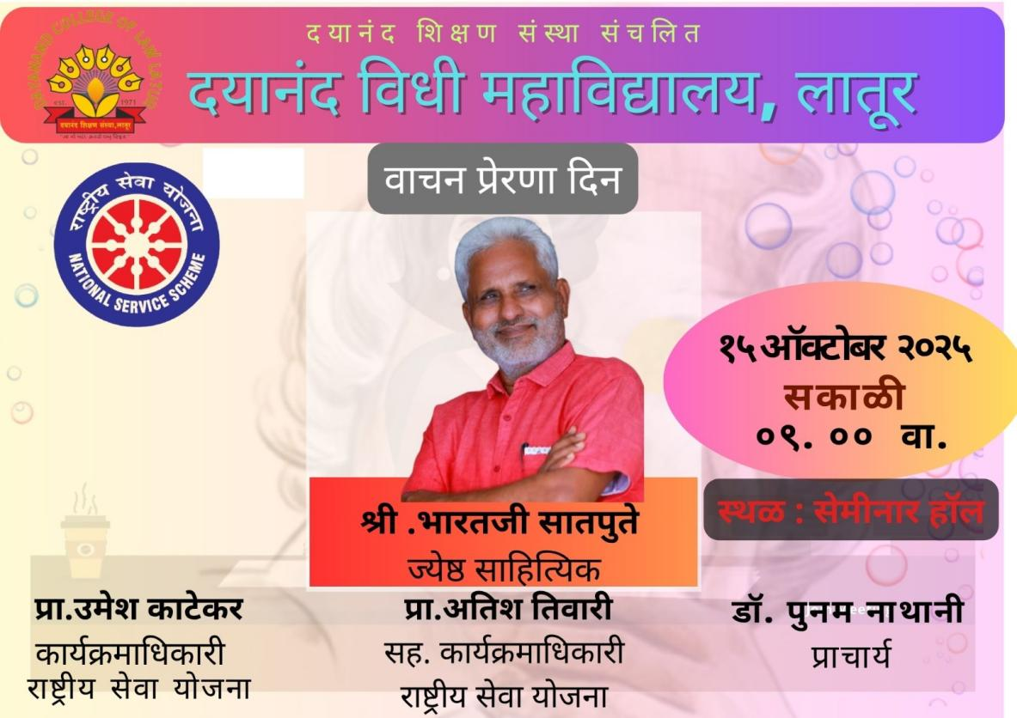
Flyer of the Programme on ‘Reading Awareness Day’ (Date - 15.10.2025).
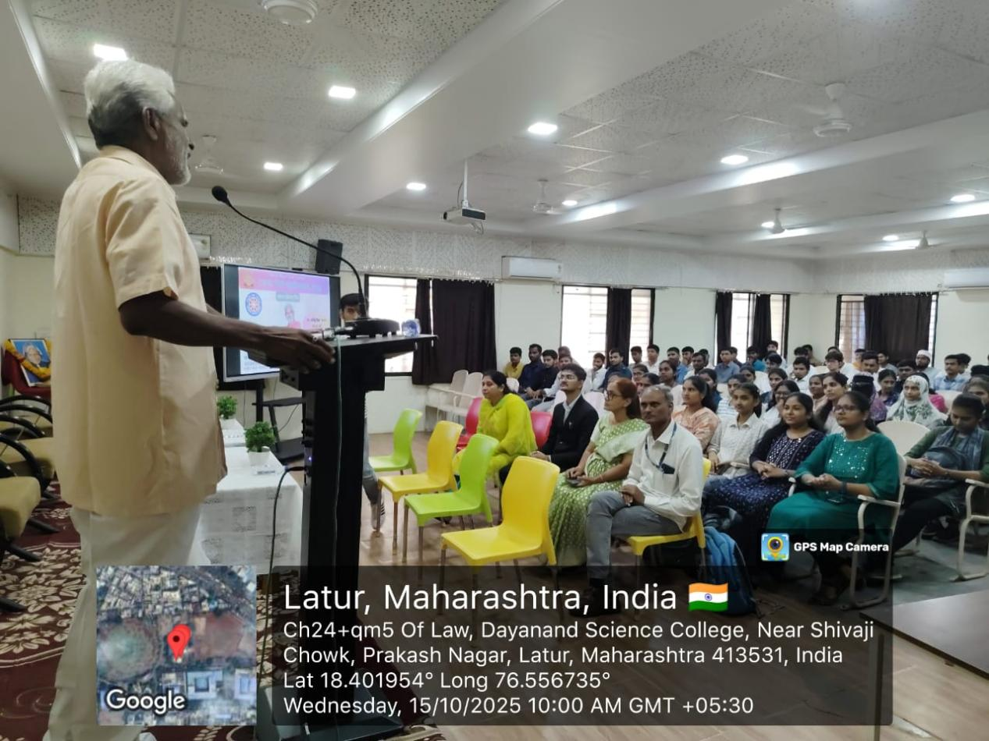
Shri. Bharatji Satpute, a renowned author, poet, and philanthropist addressing the students on the occasion of ‘Vachan Prerana Din’ (Date - 15.10.2025).

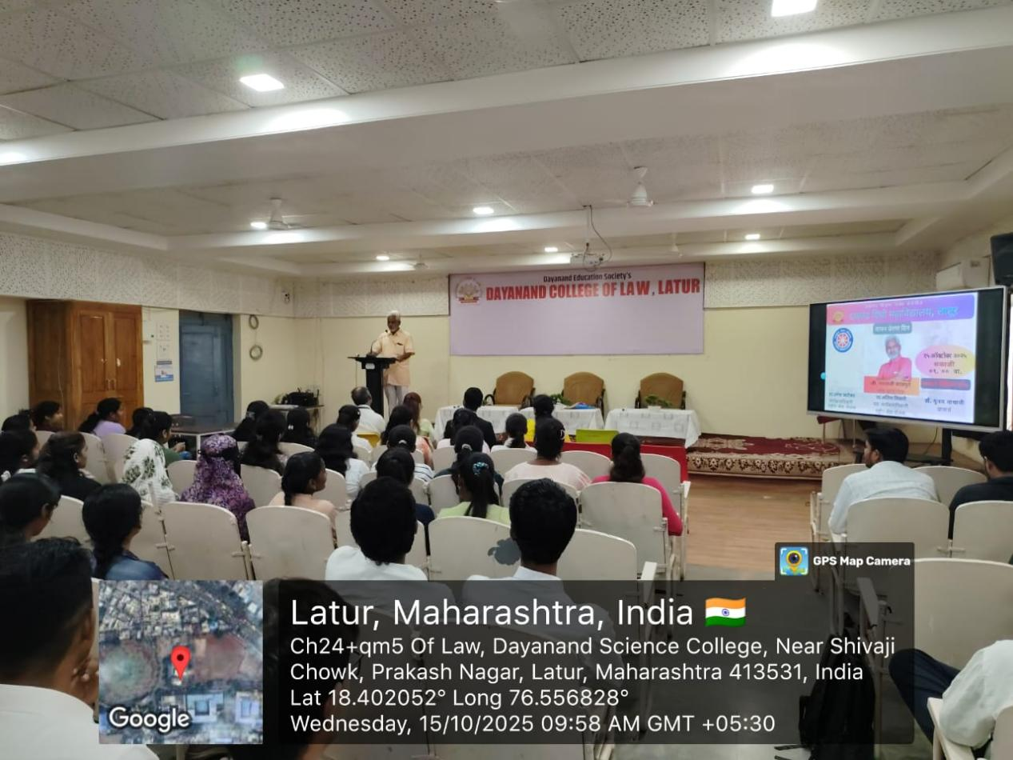
Shri. Bharatji Satpute, a renowned author, poet, and philanthropist addressing the students on the occasion of ‘Vachan Prerana Din’ (Date - 15.10.2025).

- National Unity Day (Date - 31.10.2025) -
The NSS Unit of Dayanand College of Law, Latur organised a programme to celebrate the birth anniversary of Sardar Vallabhbhai Patel (The Iron Man of India) as ‘National Unity Day’ on 31.10.2025.
At the outset, Dr. Poonam Nathani, Principal offered a floral tribute to the portrait of Sardar Patel. The staff and students also paid homage to Sardar Patel.
Later, Asst. Prof. Umesh Katekar, Programme Officer, NSS provided valuable information about Sardar Patel’s childhood, education, advocacy, key role played by him in the national freedom struggle for independence, maintainance of unity and integrity of india and the like. Then, the ‘Unity Pledge’ was given to the participants which was read by Asst. Prof. Atish Tiwari.
This programme was participated by the members of the staff and students.

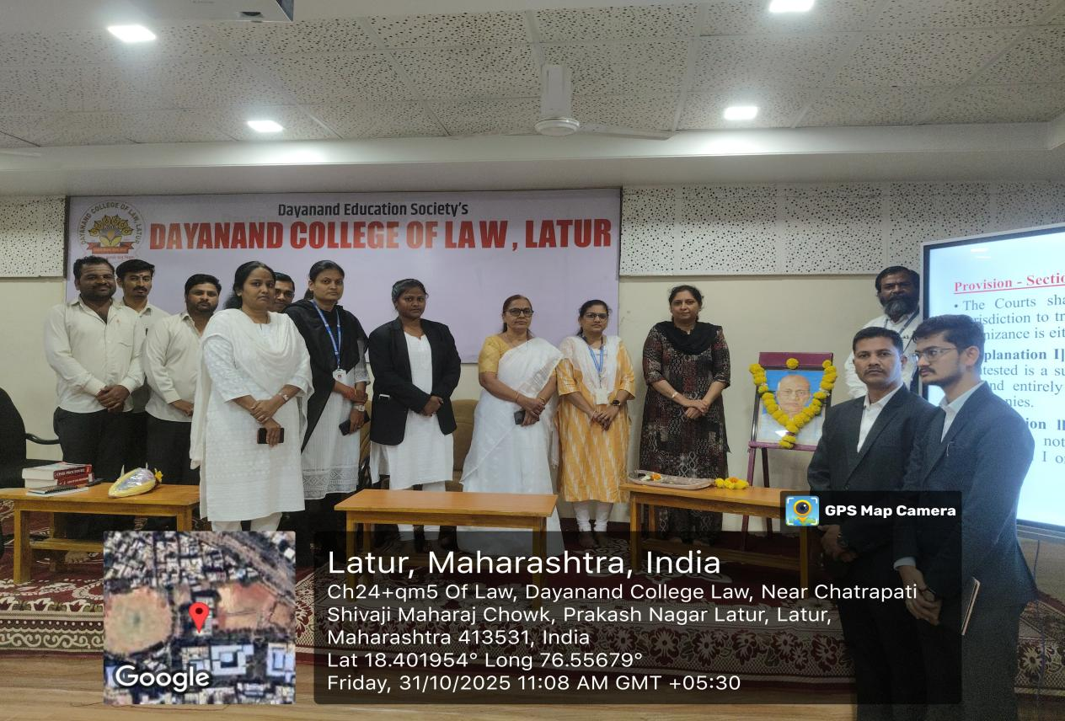
Dr. Poonam Nathani, Principal and staff members paying floral tribute to the portrait of Sardar Vallabhbhai Patel (Date - 31.10.2025).

- ‘Vande Mataram’ Group Singing (Date - 07.11.2025) -
At Dayanand College of Law, Latur, on 07.11.2025, a special program titled “Vande Mataram Group Singing” was organized by the National Service Scheme (NSS) department on the occasion of the 150th anniversary of the “Vande Mataram” song.
At the beginning of the program, the I/C Principal of the college, Dr. Sangeeta Mahajan, highlighted the divinity and significance of the song “Vande Mataram” and conveyed a message of patriotism and national unity to all present.
On this occasion, NSS Programme Officer Prof. Umesh Katekar provided a detailed overview of the historical background of the “Vande Mataram” song. He informed the students about the Indian freedom struggle, the composition of the song by Bankim Chandra Chatterjee, its importance, and how it instilled a strong sense of patriotism among the common people of India.
Following this, all participants enthusiastically and collectively sang the song “Vande Mataram.” Students, teaching staff, and non-teaching staff actively participated with great enthusiasm.
This program strengthened the sense of national pride and unity among the students. The group singing created an atmosphere filled with patriotism and solidarity within the college.
The program was compered and concluded with a vote of thanks by the Programme Officer. The success of the program was made possible through the efforts of Assistant Programme Officer Prof. Atish Tiwari, Prof. Shamrao Patil, Mrs. Jayashree Kulkarni and all other participants.
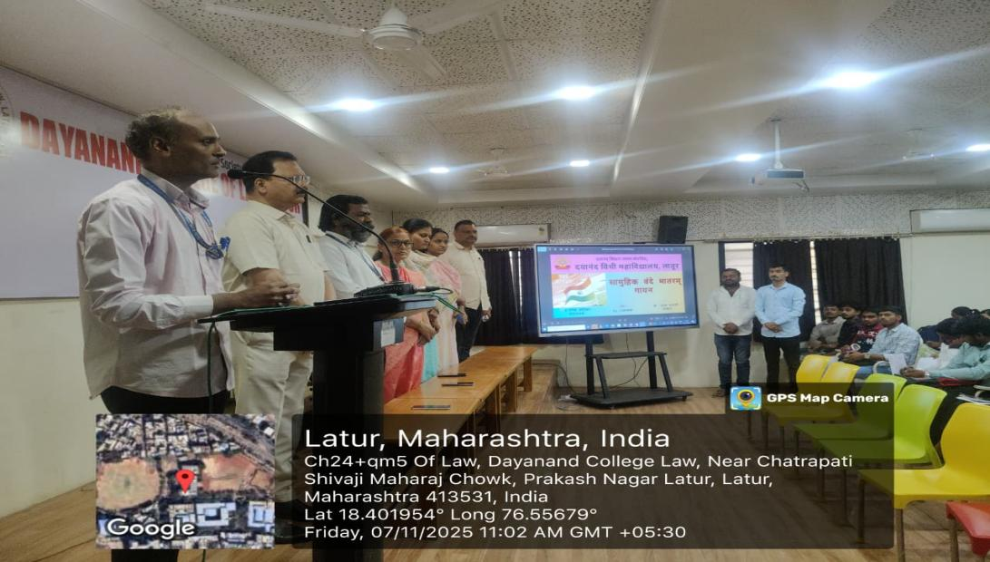
Asst. Prof. Umesh Katekar, Programme Officer, NSS addressing the students on the occasion of ‘Vande Mataram Group Singing’ at Dayanand College of Law, Latur (Date - 07.11.2025).

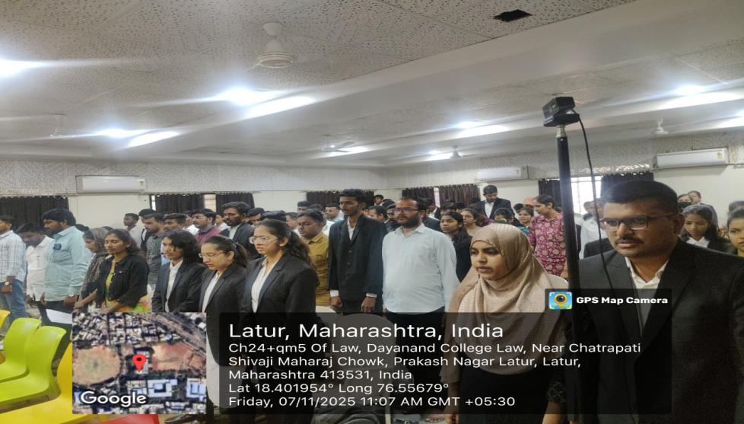
The students singing ‘Vande Matram Song’. (Date - 07.11.2025).

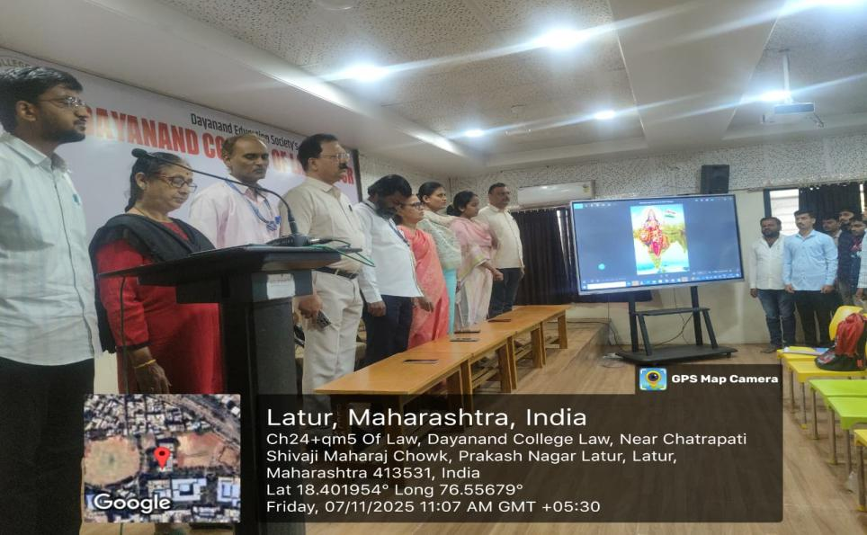
The Teaching & Non-Teaching Staff and students singing ‘Vande Mataram Song’ on the occasion of 150th Anniversary of this song. (Date - 07.11.2025).
- Celebration of Pandit Nehru Jayanti (Date - 14.11.2025) -
On 14.11.2025, NSS, Dayanand College of Law, Latur organised a programme to pay tribute to the First Prime Minister of Independent India, the Framer of Modern India Pandit Jawaharlal Nehru on his Birth Anniversary.
In the beginning, Dr. S.A. Mahajan Madam, I/C Principal paid homage to Pandit Jawaharlal Nehru with wreath by offering garland. The Teaching, Non-Teaching Staff & the students also paid homage to Panditji.
Later, one of the students of BA.LL.B 1st year, Mr. Vaibhav Kamble gave a brief note on Life, socio-political work, literary contribution of Panditji. The students, faculty & office staff were present in this programme.
Asst. Prof. Meghamala Kamble took efforts to conduct this programme, who also anchored it and proposed the vote of thanks.

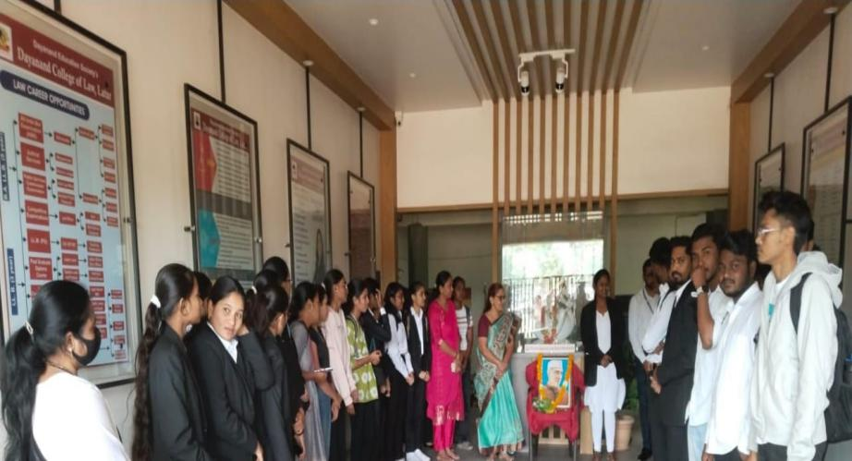

Celebration of Pandit Nehru Birth Anniversary at Dayanand College of Law, Latur (Date - 14.11.2025).

- Celebration of Birsa Munda Birth Anniversary (JanJati Gaurav Din) (Date - 15.11.2025) -
On 15.11. 2025, the National Service Scheme (NSS) Department of Dayanand College of Law, Latur, celebrated the birth anniversary of Bhagwan Birsa Munda as “Janjati Gaurav Diwas” with great enthusiasm.
At the beginning of the program, Dr. Sangeeta Mahajan, I/C Principal paid floral tribute to Bhagwan Birsa Munda by offering a garland to his portrait. Thereafter, all present paid their respects to him.
Following this, a student of the college, Ms. Swaroopa Jagdale, presented information about the life and contributions of Bhagwan Birsa Munda. Her presentation covered his birth, childhood, the rebellion he led against British rule, his movement for the rights of tribal communities, his views on religious conversions, and his struggle against social evils prevalent in tribal society.
The teaching and non-teaching staff, and students were present at this occasion. The program was organized, introduced, and concluded with a vote of thanks by Dr. Amol Shinde.
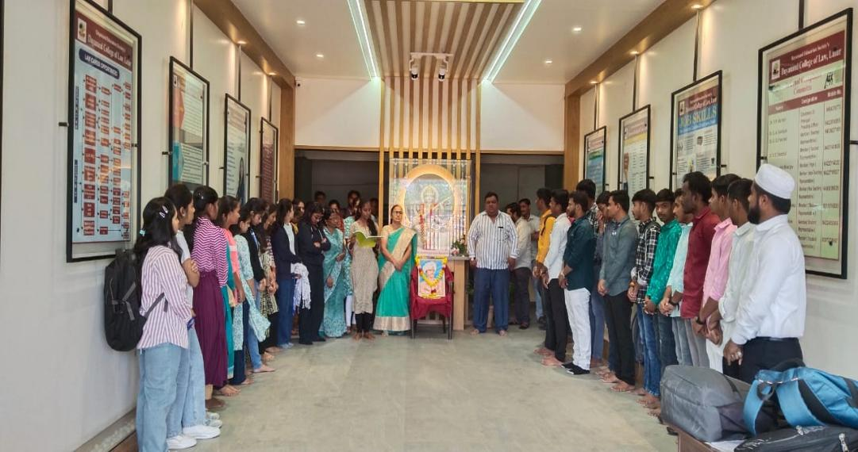
Celebration of Birth Anniversary of Birsa Munda as Janjati Gaurav Diwas at Dayanand College of Law, Latur (Date - 15.11.2025).

- Celebration of Birth Anniversary of Savitribai Phule (Date - 03.01.2026) -
On 03.01.2026, NSS, Dayanand College of Law, Latur celebrated Birth Anniversary of Krantijyoti Savitribai Phule in the College. She was the first female Teacher and Head Mistress, social reformer, educationalist, great advocate of Women Liberation & Empowerment, and feminist of Maharashtra.
At the outset, Dr. Poonam Nathani, Principal offered chaplet to the image of Savitribai. The Staff members also paid homage to Savitribai then.
Later, the Programme Officer shared the valuable information regarding the childhood, marriage, social and educational works, literature, etc. of Savitribai.
This programme was attended by the members of Teaching and Non-Teaching staff of the College. It was anchored by and vote of thanks was proposed by Asst. Prof. Atish Tiwari, Asst. Programme Officer.
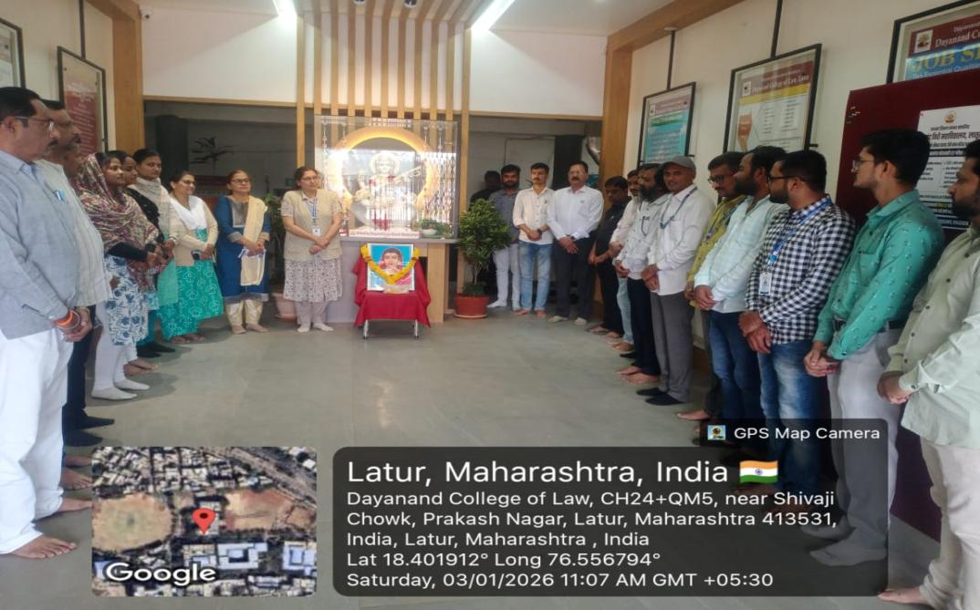
Asst. Prof. Umesh Katekar, Programme Officer, NSS sharing the information on the life-work of Krantijyoti Savitribai (Date - 03.01.2026).
- Swami Vivekananda & Rajmata Jijau Jayanti (Date - 12.01.2026) -
On 12th January 2026, NSS, Dayanand College of Law, Latur organized a Programme to celebrate the Birth Anniversaries of Swami Vivekananda, influential Indian Hindu monk and philosopher and Rajmata Jijau, mother of Chhatrapati Shivaji Maharaj, the founder of the Maratha Empire in the College.
At the outset, Dr. Poonam Nathani, Principal offered garlands to the images of Swami Vivekananda and Rajmata Jijau. The participants also paid homage to these great personalities then.
Later, Miss Kasturi Pathrudkar, NSS volunteer shared information about the great works of Swami Vivekananda including his childhood, the practice, profession and propogation of Hinduism he made, his philosophy, selfless service and the like.
Mr. Amit Kathare, NSS Volunteer then shared the information about the lifeworks of Rajmata Jijau including her childhood, vision, courage, foundation of Maratha Empire, her administrative qualities and the like.
This Programme was participated by teaching and non-teaching members and students. It was anchored by Asst. Prof. Atish Tiwari and vote of thanks was proposed by Asst. Prof. Umesh Katekar, Programme Officers.

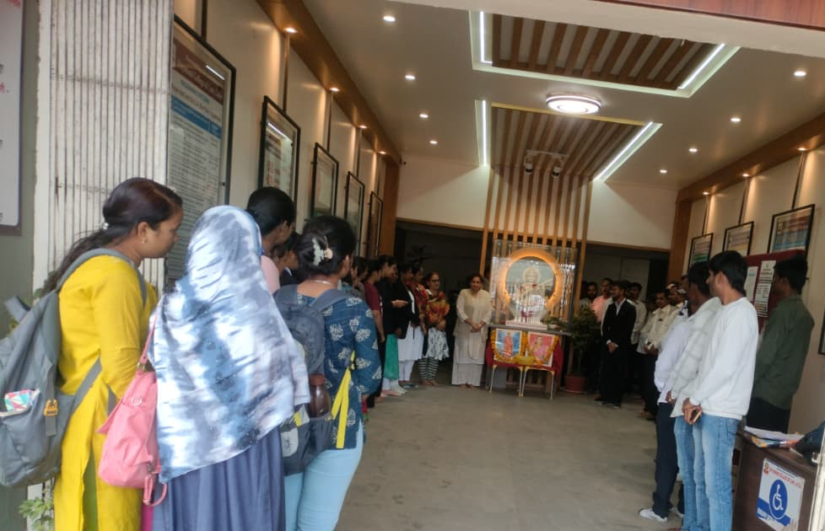
Celebration of Birth Anniversaries of Swami Vivekananda and Rajmata Jijau at Dayanand College of Law, Latur (Date - 12.01.2026)
- Voting Awareness Programme (Date - 14.01.2026) –
On 14.01.2026, a ‘Voting Awareness Programme’ was arranged by the NSS, Dayanand College of Law, Latur to spread voter literacy among the students. The objective of this programme was to spread voting awareness, promote civic responsibility and insist the participation in the democratic process by all.
At the outset, Dr. Poonam Nathani, Principal emphasized on the participation in the voting festival of democracy by exercising the constitutional right to vote by all. She also encouraged and greeted all for casting votes in elections.
In this programme, Asst. Prof. Umesh Katekar, Programme Officer shared the information about the importance of right to vote and its exercise, disadvantages of its non-exercise, value of voting, judicious exercise of right to vote without any fear or pressure, etc.
Later, Asst. Prof. Atish Tiwari, Programme Officer administered the ‘Voting Pledge’ to the participants. This Pledge underlines a commitment to be made by individuals to vote in elections, which signifies their engagement in the democratic process, promotion of the value of democracy and encourage others to participate, leading to a more representative and accountable government, and to vote in every election fearlessly and without being influenced by considerations of religion, race, caste, community, language or any inducement.
This programme was participated by the Teaching and Non-Teaching Members and students. It was anchored by Asst. Prof. Umesh Katekar who also proposed vote of thanks.
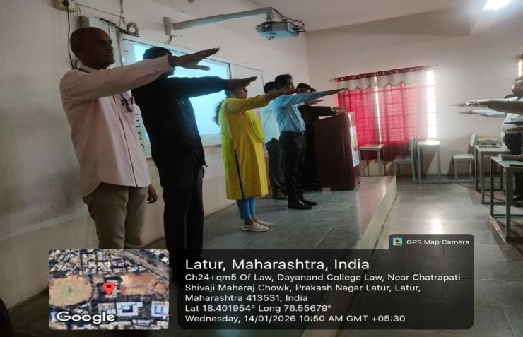
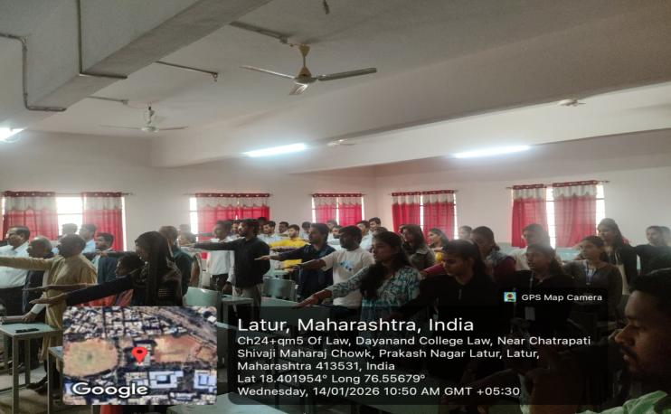
The Staff and students taking ‘Voting Pledge’ during the Voting Awareness Programme (Date - 14.01.2026)
- Celebration of birth anniversaries of Netaji Subhashchandra Bose and Balasaheb Thakare (Date - 23.01.2026) -
The NSS Unit of Dayanand College of Law, Latur organized a programme on 23rd January 2026 to pay tribute to Netaji Subhashchandra Bose and Balasaheb Thakare on their birth anniversaries. Netaji Subhashchandra Bose’s birth anniversary is observed as “Parakram Din” to honor his courage, patriotism, and remarkable contribution to India’s freedom struggle.
The programme began with Dr. Poonam Nathani, I/C Principal, offering floral tributes to the images of Netaji Bose and Balasaheb Thakare. Later, Asst. Prof. Atish Tiwari shared insightful information about Netaji’s life, including his early education, formation of the Azad Hind Fauj, and his immense role in the freedom movement.
Thereafter, he also highlighted the life and work of Balasaheb Thakare, focusing on his leadership, contribution to Maharashtra, and efforts toward social and cultural development.
The programme witnessed active participation from teaching and non-teaching staff, NSS volunteers, and students. The event was anchored by Programme Officer Asst. Prof. Umesh Katekar, and who also proposed vote of thanks.
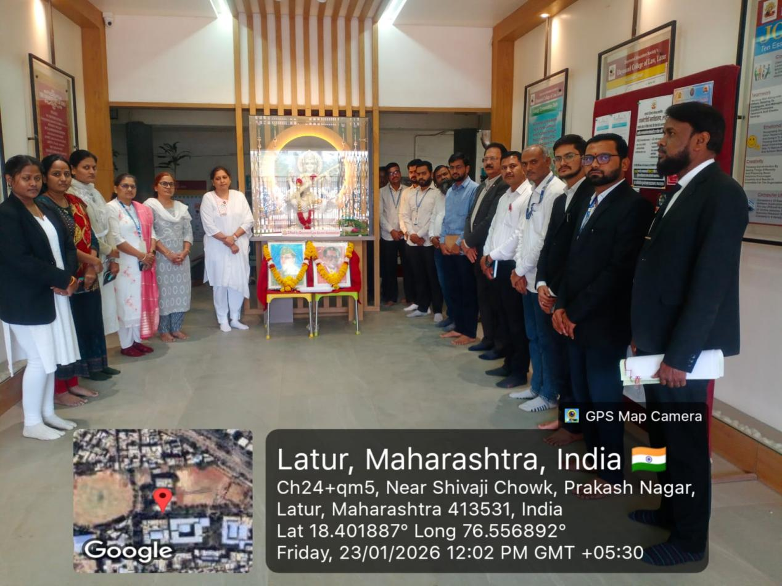
- Blood Donation Camp (Date - 16.02.2026) -
Dayanand College of Law, Latur organized a Blood Donation Camp on 16.02.2026 in association with Maheshwari Vidya Pracharak Mandal, Latur. The camp was conducted with the cooperation of the staff of Bhalchandra Blood Bank, Latur.
The program was inaugurated by Shri Laxmiramanji Lathoti, President of Dayanand Education Society, in the presence of Shri Rameshji Biyani, Secretary, and other dignitaries.
Students and staff members actively participated in the camp and donated blood with great enthusiasm, showing their commitment to social service. The camp was successfully conducted and contributed to spreading awareness about the importance of blood donation.
The camp not only helped in collecting valuable blood units but also played a vital role in creating awareness about the life-saving impact of blood donation. The entire program was conducted in an organized and disciplined manner, ensuring donor safety and comfort throughout the process.
This camp recorded active guidance and participation by Dr. Poonam Nathani, Principal. Asst. Prof. Umesh Katekar & Asst. Prof. Atish Tiwari, Programme Officers and volunteers took efforts to make this camp successful.
窗体顶端

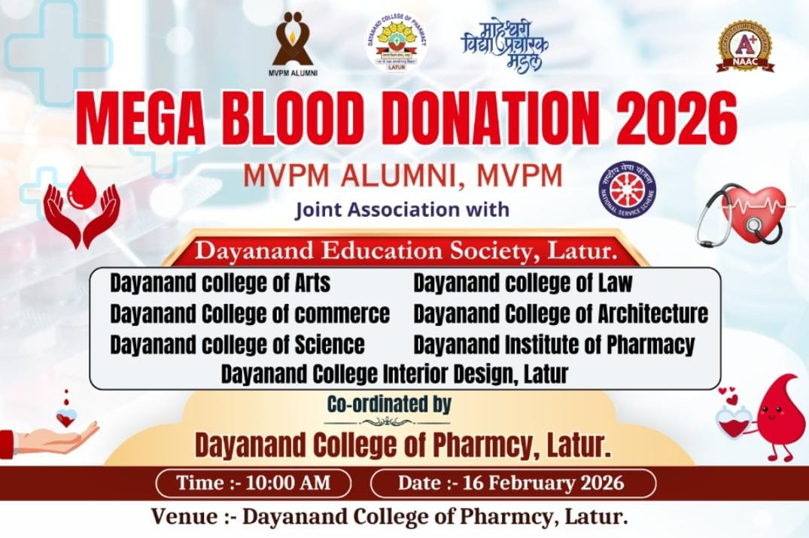
Flyer of the Blood Donation Programme (Date - 16.02.2026).

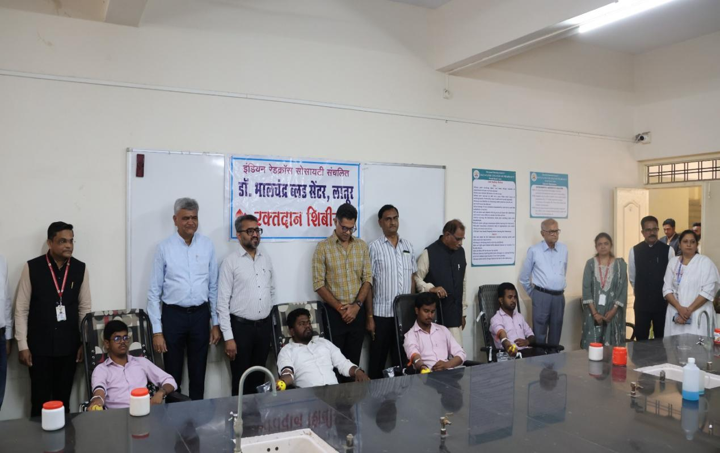
Honourable Shri. Laxmiramanji Lahoti, President, Shir. Rameshji Biyani, Secretary, Dr. Poonam Nathani, Principal and other digniraries congratulating the blood donors during the camp (Date - 16.02.2026).
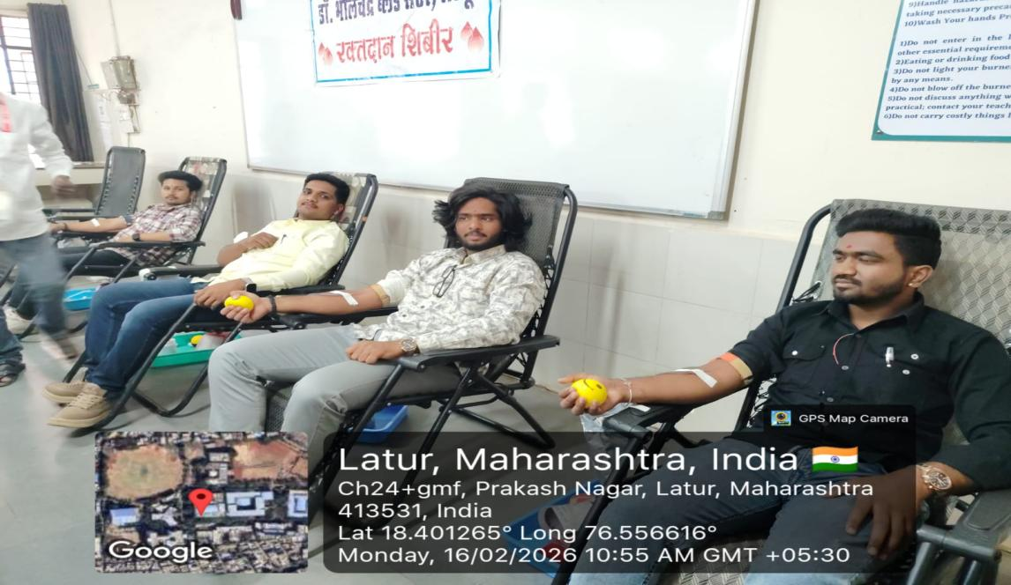
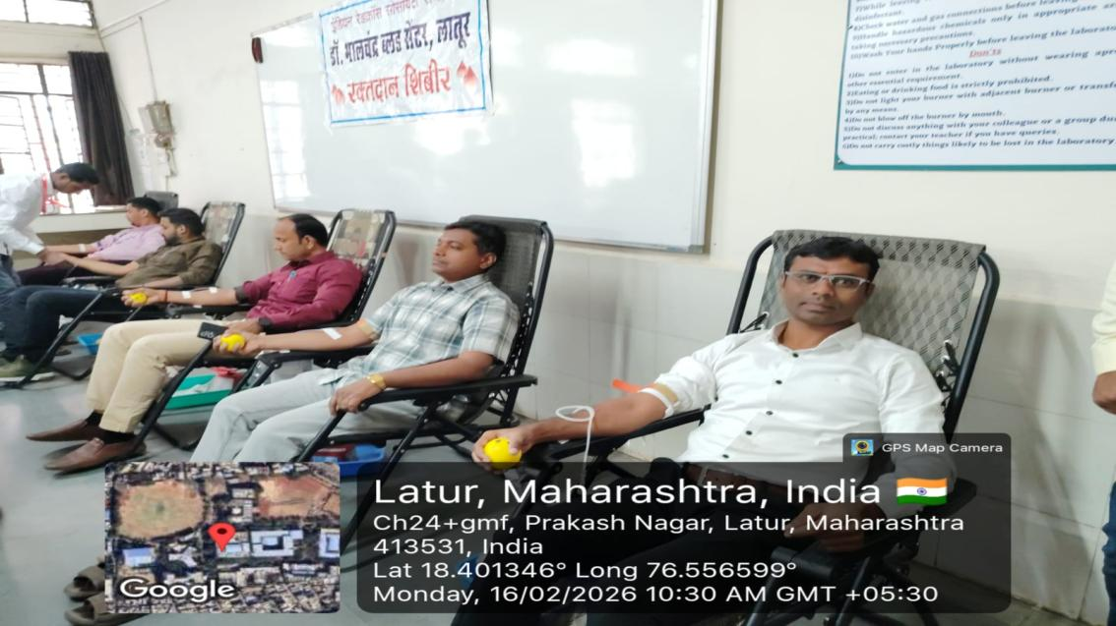
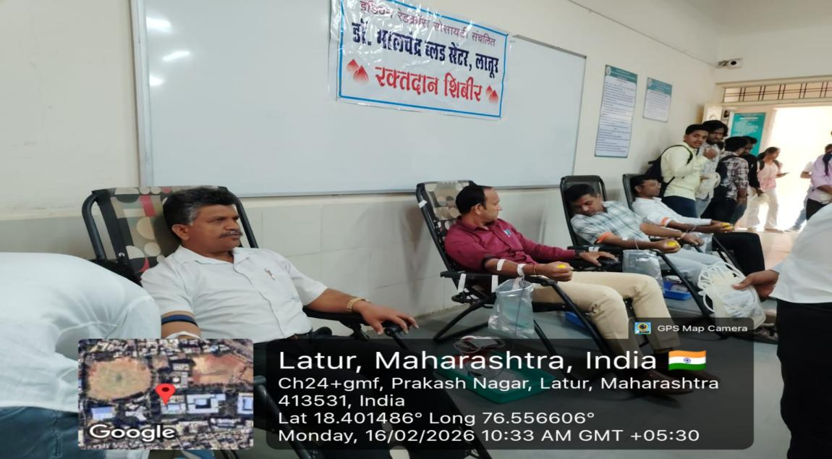
The students of the Dayanand College of Law, Latur donating the blood during the Blood Donation Camp (Date - 1602.2026).
- Annual Special Residential Camp (Date - 21.02.2026 - 27.02.2026) -
The Annual Special Residential Camp of NSS, Dayanand College of Law, Latur was organised during 21st February to 27th February 2026 at Bhoisamudraga, Tq+Dist. Latur. The theme for this Camp was “Youth for Sustainable Development: Water Conservation and Waste Land Development”. During this 7 Day Residential Camp, following various socio-legal activities were conducted.
The inauguration of the Camp was conducted on 21st February 2026 at Bhoisamudraga. Dr. Poonam Nathani, Principal was the Chairperson of this programme. Shri. Hanmantraoji Gaikwad, a well known social worker of Bhoisamudraga, Shri. Baliramji Salunke, Sarpanch, Shri. Ashish Nirude, Gramsewak, Shri. Raosaheb Gaikwad, Chairman, Tantamukti Samiti, and other dignitaries from the village of Bhoisamudraga, volunteers and Asst. Prof. Umesh Katekar, Asst. Prof. Atish Tiwari, Programme Officers, Asst. Prof. Shital Ghute and other staff members of Dayanand College of Law, Latur, were present during this inauguration programme.

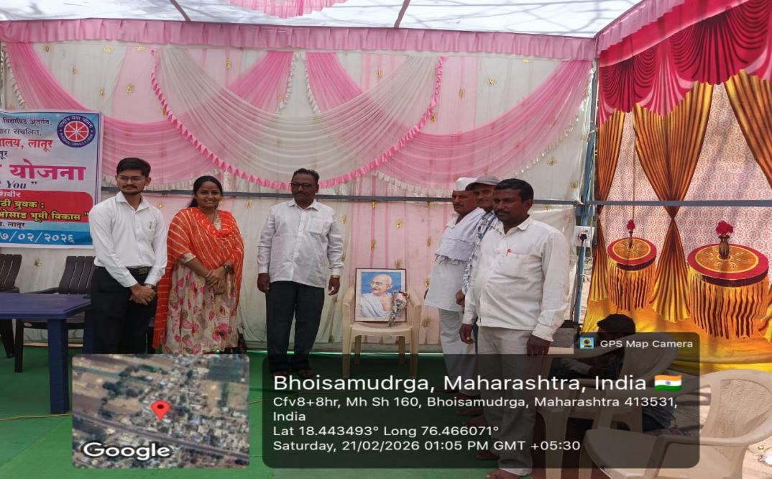
The Annual Special Camp was inaugurated by offering garlands to the portrait of Mahatma Gandhi. Chairperson of this programme. Shri. Hanmantraoji Gaikwad & other dignitaries, Asst. Prof. Shital Ghute, Asst. Prof. Atish Tiwari & Asst. Prof. Umesh Katekar, Programme Officers were present (Date - 21.02.2026).
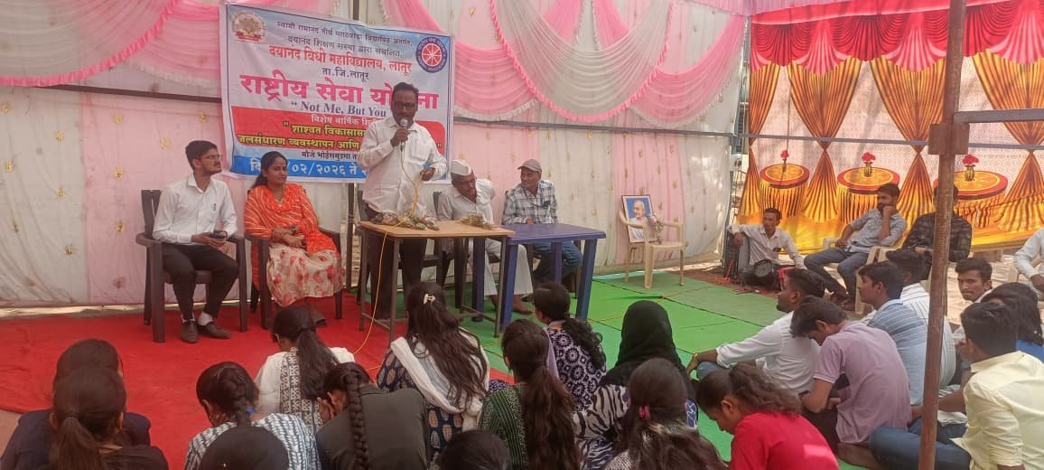
Shri. Hanmantraoji Gaikwad, Chairperson addressing the volunteers and villagers during the inauguration of the Annual Special Camp at Bhoisamudraga (Date - 21.02.2026).
On the Second Day of the Camp (Date - 22.02.2026), in the morning session, a cleanliness programme was organized in the village. During the programme, the volunteers enthusiastically participated and made the premises clean. It was emphasized that the use of plastic should be minimized, as this helps in maintaining ecological balance. All the participants took pledge to reduce plastic usage by promoting the use of reusable items, thereby helping to curb plastic consumption.
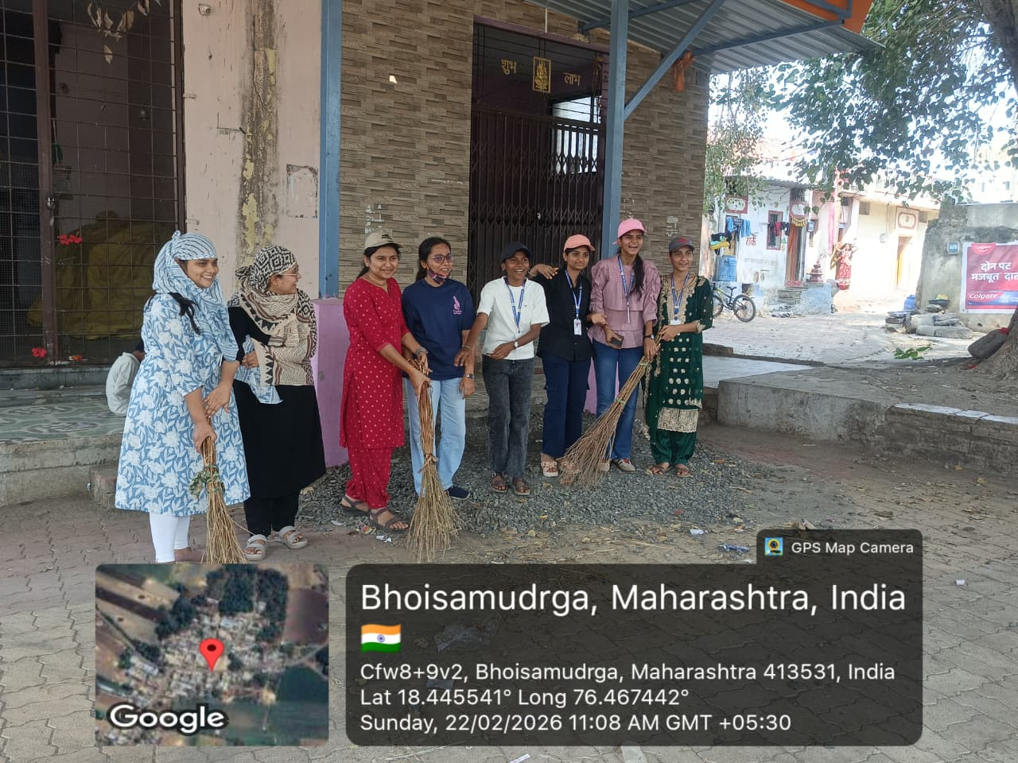
The volunteers cleaning the premises at Bhoisamudraga (Date - 22.02.2026)
In the afternoon session, Dr. Balaji Sonawane was invited to address on the topic ‘Role of Youth in the Water Conservation and Waste Land Development“. During his guidance, he focused on the power of youth and their role in water conservation and waste land development. He emphasized on creating awareness among youth to take initiative in water conservation and to bring wastelands under cultivation, promoting activities such as animal husbandry, tree plantation, dairy farming, and beekeeping.
The program was attended by NSS Programme Officer Prof. Umesh Katekar, Prof. Shubhangi Panchal, and Prof. Atish Tiwari from Dayanand Law College. All NSS volunteers of the college, along with a large number of villagers, were also present.
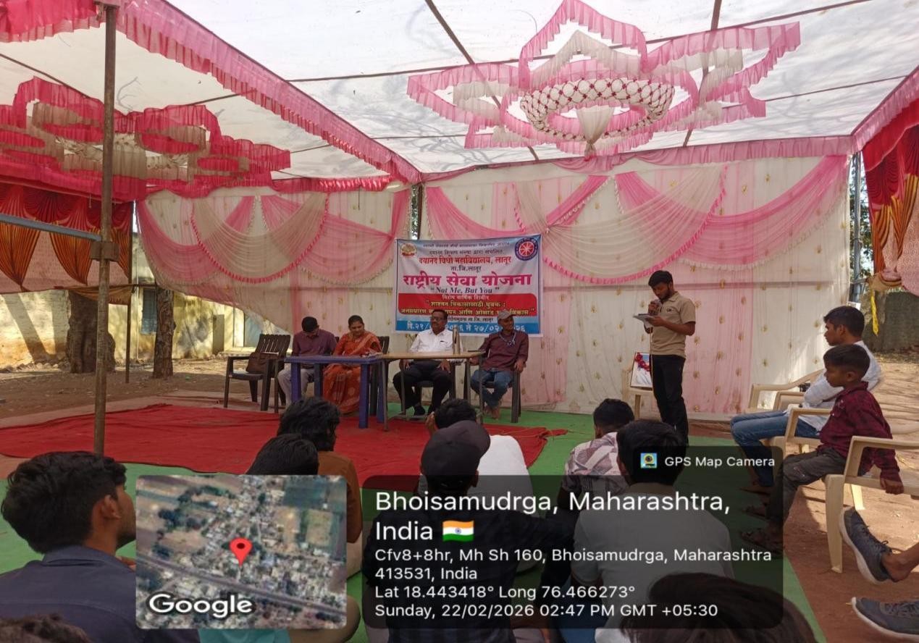
Dr. Balaji Sonawane, Former Principal, Shivneri College, Shirur Anantpal delivered an enlightening lecture on the topic ‘Role of Youth in the Water Conservation and Waste Land Development’ during the Camp (Date - 22.02.2026).
In the evening session, for the villagers of Bhoisamudraga a socially enlightening kirtan was organized. Shri. H.B.P. Sushil Maharaj Deshmukh from Pandharpur was invited to address the villagers. Through his discourse, he addressed issues such as eradication of superstition, importance of tree plantation, environmental protection, gender equality, prohibition of child marriages and concerns about the younger generation being adversely influenced by fashion and addiction in a rapidly changing society. Through meaningful abhangas (devotional verses of saints), he effectively conveyed strong messages of social awareness during his kirtan.
This Kirtan was taken benefit of by the villagers of Bhoisamudraga and well applauded by them.
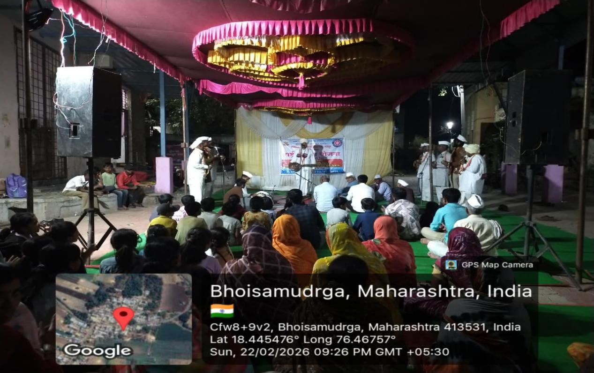
Shri. H.B.P. Sushil Maharaj Deshmukh from Pandharpur enlightening the villagers of Bhoisamudraga during the Special Annual Camp (Date - 22.02.2026).
On the third day of the camp (Date - 23.02.2026), in the morning session, a “Free Veterinary Camp” was organized in the village of Bhoisamudraga in collaboration with Veterinary Hospital, Jewali. In this Camp, the farmers got their cattle like cows, buffaloes, goats etc. Checked, diagnosed and vaccinated by the Staff of the Hospital. The Staff provided the necessary treatment to the cattle along with the proper medications. Dr. Vyankatrao Sonawane,, Veterinary Officer and the staff, volunteers and Programme Officers took efforts to make this camp successful.
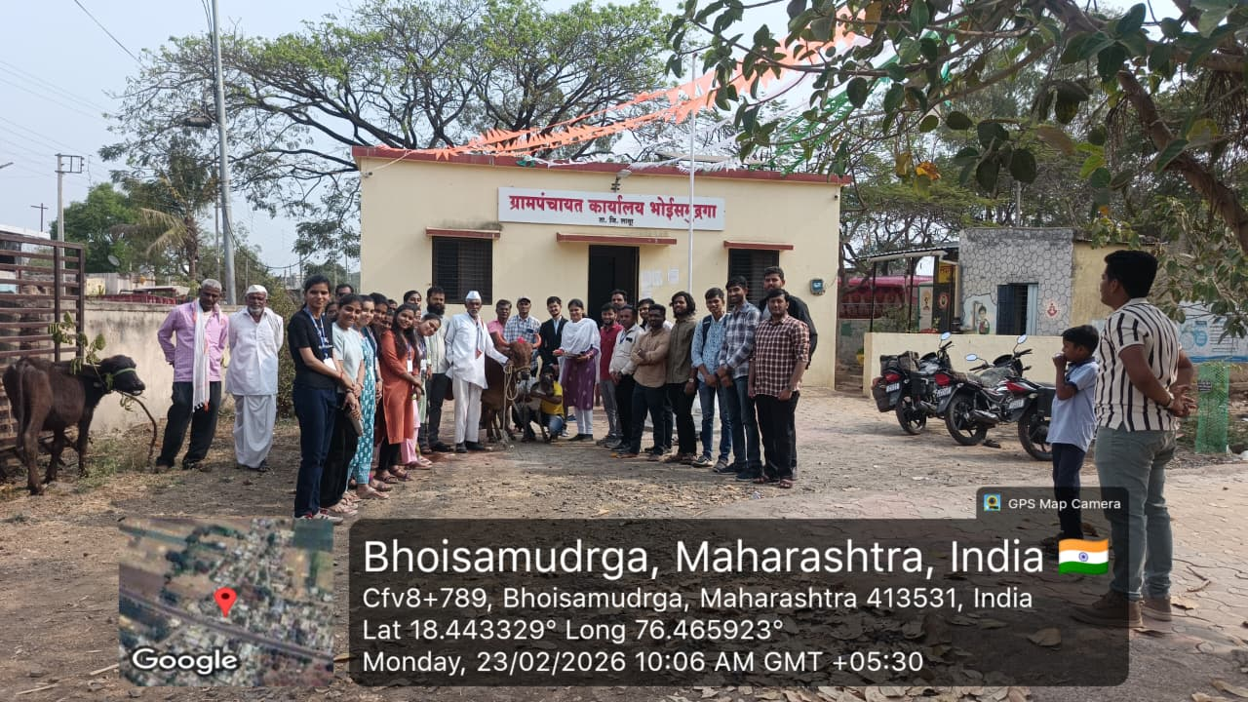
Dr. Vyankatrao Sonawane and Staff providing veterinary services in the “Free Veterinary Camp” at Bhoisamudraga. (Date - 23.02.2026).
In the afternoon session, on the occasion of Karmayogi Sant Gadgebaba birth anniversary, a lecture on the topic ‘Equality, Cleanliness and Education - Trilogy of Sant Gadgebaba’ was organised. Dr. Vitthal Jadhav, Librarian, Dayanand College of Commerce, Latur graced the occasion. He shared the information about the life-works of Gadgebaba, his childhood, education, unparalleled works for the betterment of society using the principles of equality, cleanliness and education.
This programme was attended by residents, Asst. Prof. Umesh Katekar, Asst. Prof. Atish Tiwari, Programme Officers, NSS, Asst. Prof. Swati Patil, staff members and the volunteers.
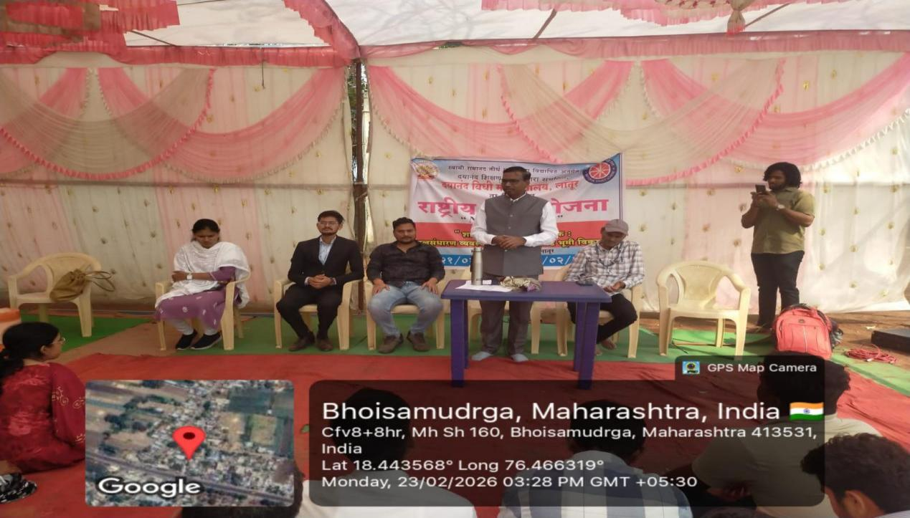
Dr. Vitthal Jadhav, Librarian, Dayanand College of Commerce, Latur delivering a keynote address on the topic ‘Equality, Cleanliness and Education: Trilogy of Sant Gadgebaba’ during the NSS Special Camp at Bhoisamudraga (Date - 23.02.2026).
窗体顶端
On the fourth day of the camp (Date - 24.02.2026), in the morning session, a program titled “National Service Scheme – Disaster Awareness” was organized. In this program, Prof. Megha Salunke from the Disaster Management Department of the University Sub-Centre provided valuable guidance on disaster prevention, types of disasters, earthquakes, floods, lightning, storms, gas leakage from cylinders, and other related topics.
Along with this, Dr. Vishal Garad and his team offered important medical and practical guidance on emergency health knowledge and the immediate measures like CPR to be taken during such situations. They also explained the importance of ambulance services in emergency management and shared relevant information such as the emergency contact number 108, Good Samaritan App and the like.
This programme was attended by students of the school and staff, villagers, Programme Officers and volunteers.

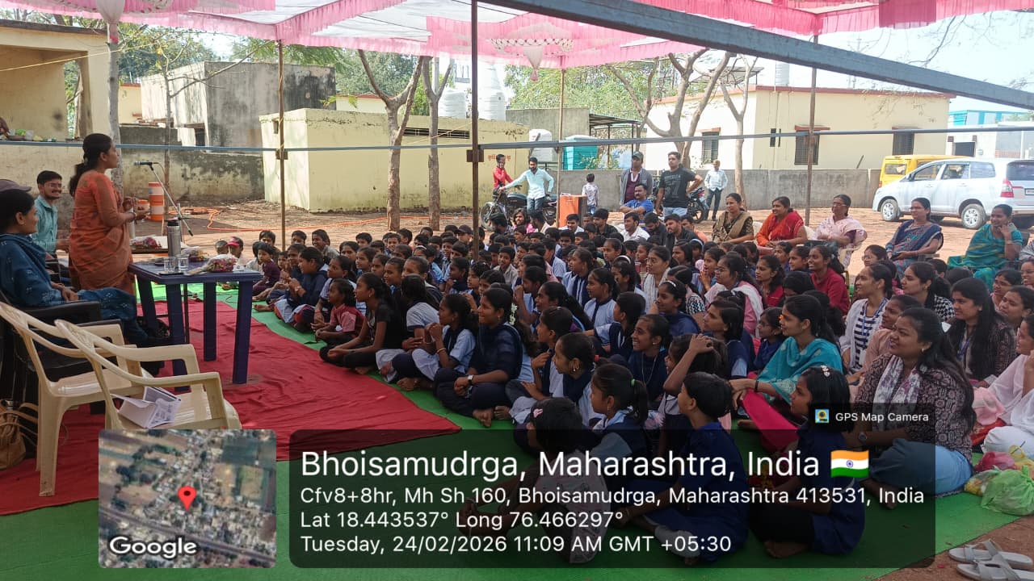
Prof. Megha Salunke, Swami Ramanand Teerth Marathwada University, Nanded Subcentre, Peth delivering a lecture on “National Service Scheme – Disaster Awareness” at Bhoisamudraga (Date - 24.02.2026).

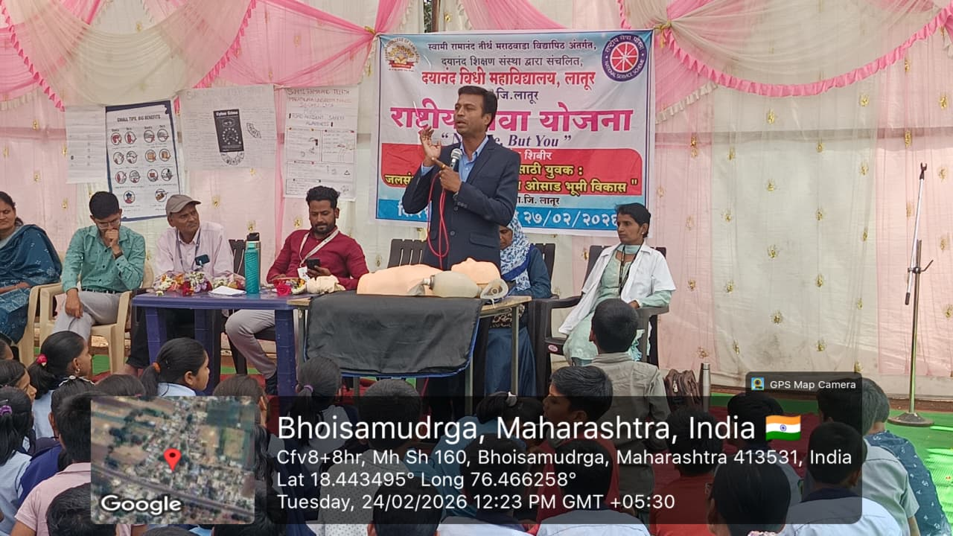
Dr. Vishal Garad, BVG-MEMS, Dial 108, District Manager, Latur addressing the participants about the essential steps to be taken in emergency medical services. (Date - 24.02.2026).

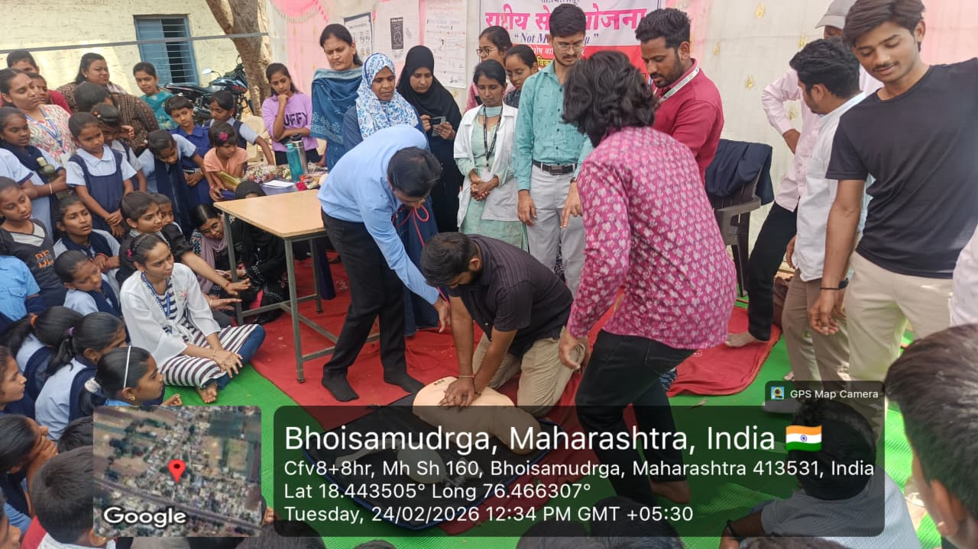
Dr. Vishal Garad tutoring the volunteers the CPR Methods during emergency medical services with demonstrations (Date - 24.02.2026).

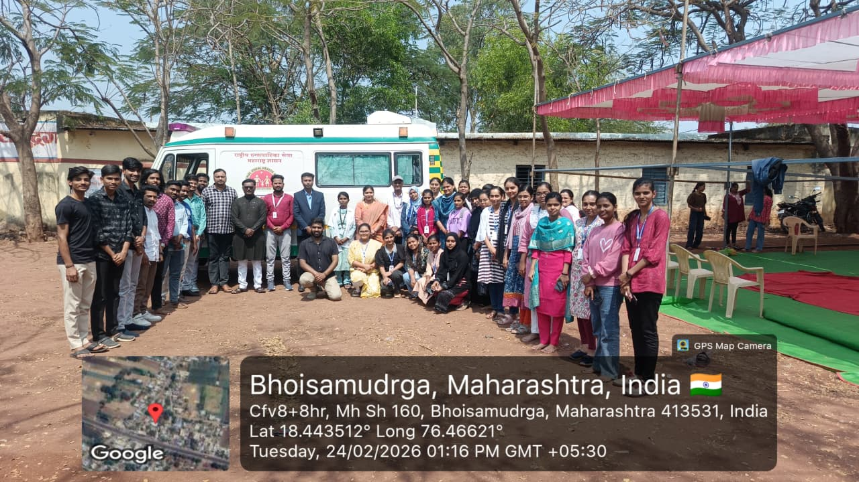
A group photo of the Disaster Management Staff, Staff of the College and volunteers with the Ambulance at Bhoisamudraga (Date - 24.02.2026).

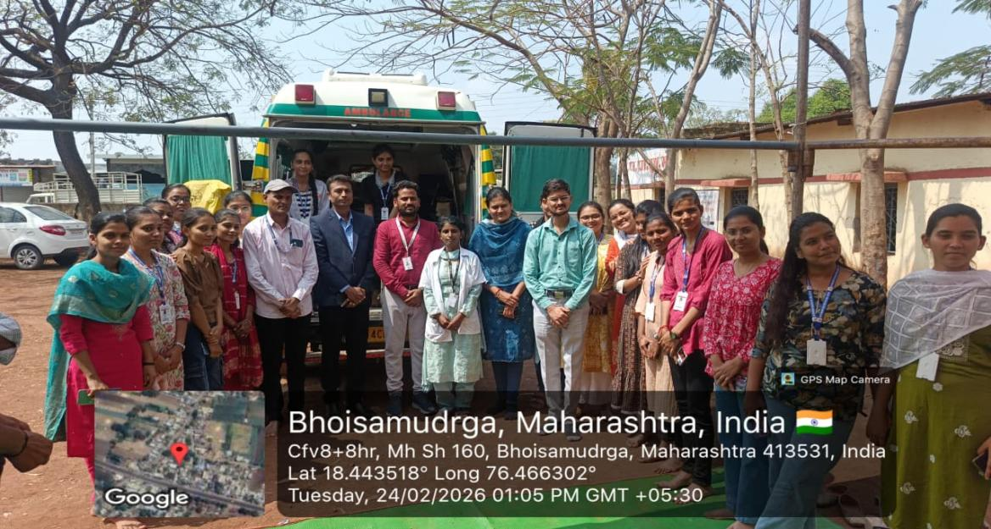
The Disaster Management Staff giving information about the features of the Ambulance to the Staff of the College and volunteers (Date - 24.02.2026).
In the afternoon session, lectures were organized on the topics “Cyber Security – Need of the Hour” and “Nation Building and the Role of Youth” by Dr. Sachin Mane and Dr. Pramod Shinde respectively.
In today’s rapidly evolving cyber era, Prof. Dr. Sachin Mane provided excellent guidance on how to take proper precautions to stay safe and also explained the relevant laws related to the cyber security. With the help of various examples the resource person spread awareness dealing with cyber security.
Similarly, Prof. Dr. Pramod Shinde, in his lecture, emphasized that if the energy of youth is properly channelized, it can significantly contribute to constructive nation-building. He also addressed the importance of good habits, civic values, patriotism, discipline in the lives of youth.
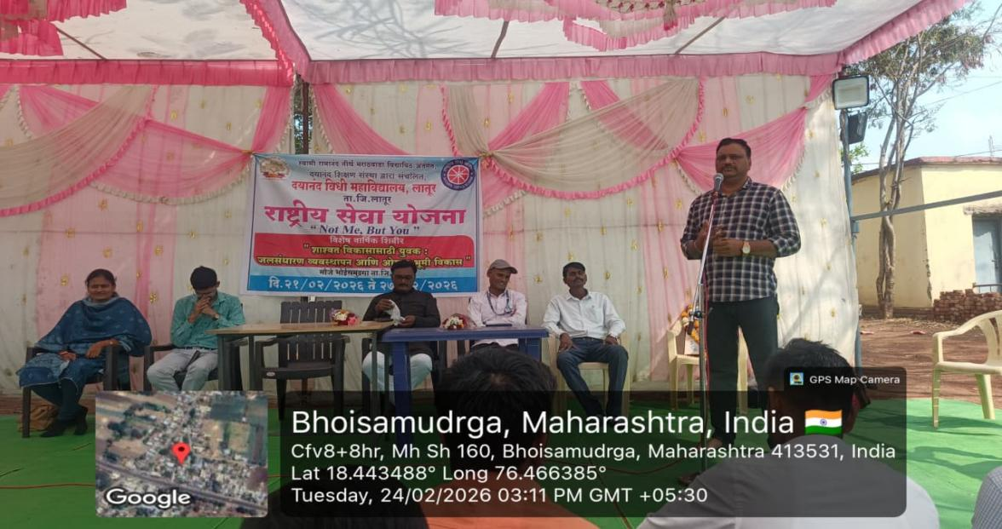
Dr. Pramod Shinde delivering a lecture on ‘Role of Youth in Nation Building’ during the NSS Special Annual Camp at Bhoisamudraga (Date - 24.02.2026).
In the evening session, child artist Prem Panchal presented a beautiful Powada (traditional ballad) on Chhatrapati Shivaji Maharaj. His performace was well received and praised by the villagers of Bhoisamudraga.

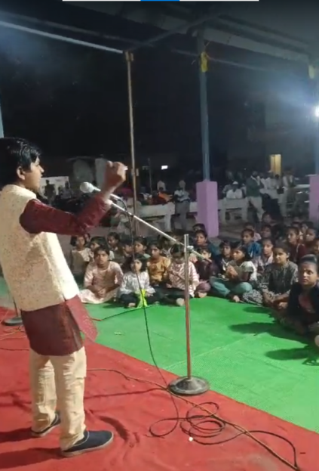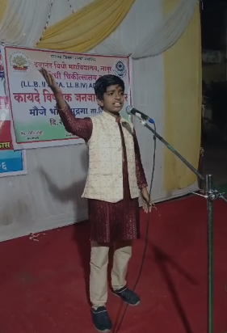

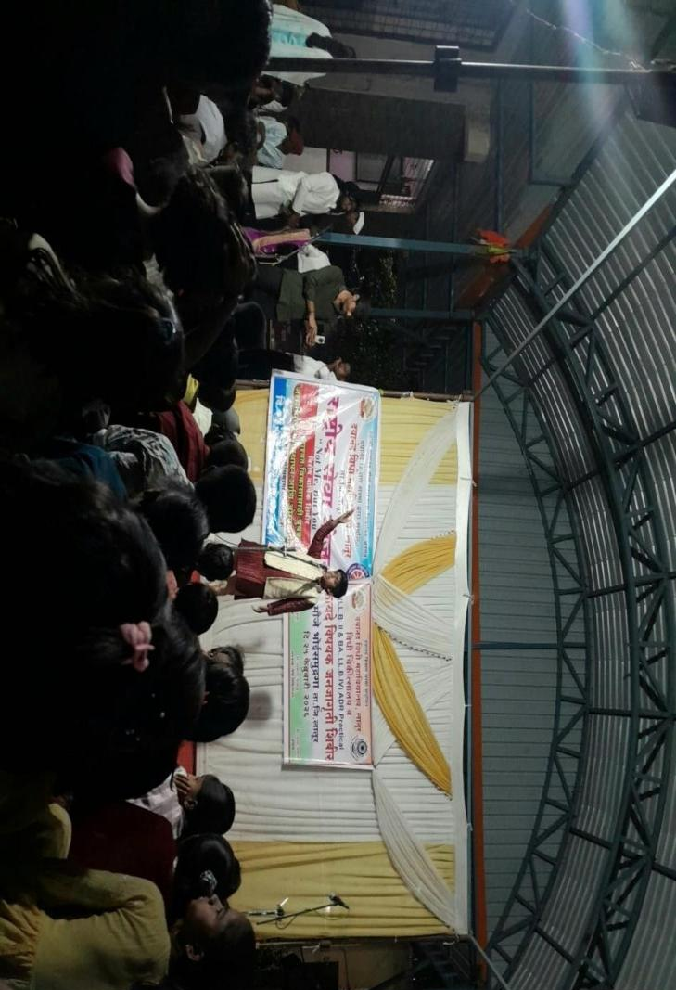
Child artist master Prem Panchal presenting a ballad (Powada) on the bravery of Chhatrapati Shivaji Maharaj during the Camp at Bhoisamudraga (Date -24.02.2026).
On the fifth day of the camp (Date - 25.02.2026), in the morning session, a “Free Health Check-up Camp” was organized in the morning session for the villagers of Mauje Bhoisamudraga. In this camp, Dr. Ashwini Narayanakar and her team, along with Lions Club and Helping Hands, Latur, conducted medical examinations of the villagers, including skin, dental, eye, and blood sugar check-ups. The villagers were also given the expert medical advice for the betterment of their health. The camp received an enthusiastic response from the villagers.
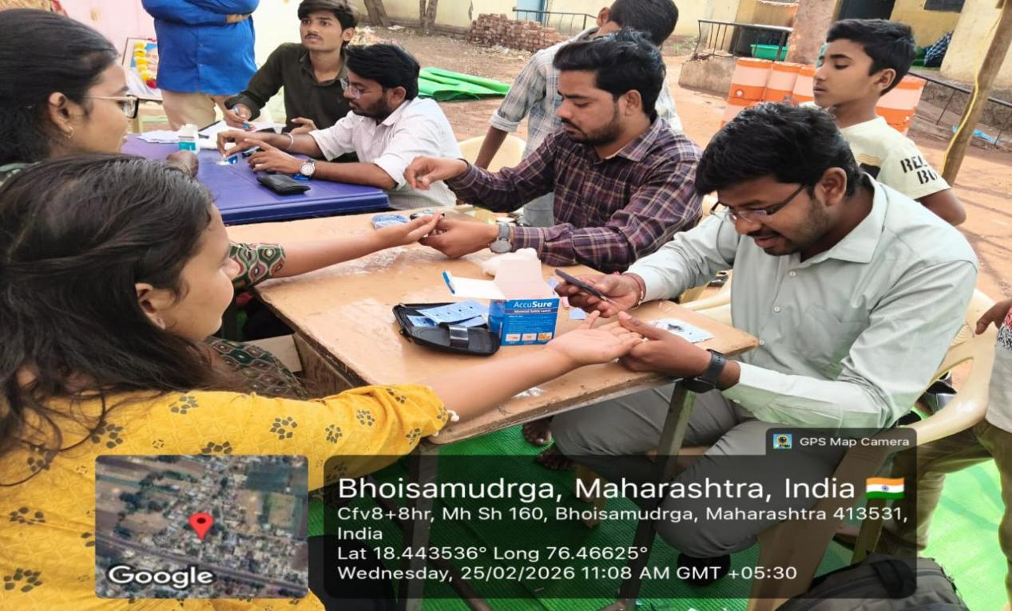
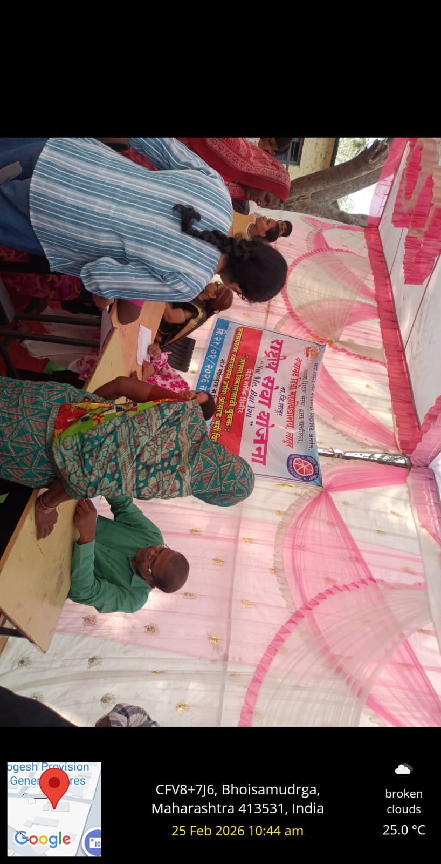
Dr. Ashwini and Dr. Ajay Narayankar giving medical guidance and services to the villagers of Bhoisamudraga during the NSS Special Annual Camp (Date - 25.02.2026).
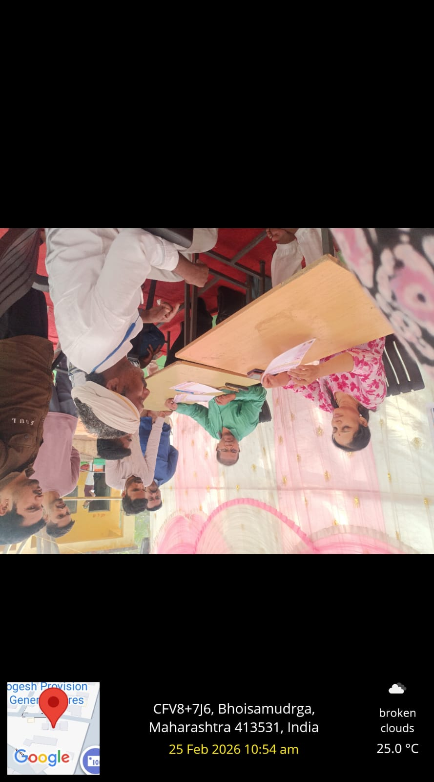
Dr. Ashwini and Dr. Ajay Narayankar giving medical guidance and services to the villagers of Bhoisamudraga during the NSS Special Annual Camp (Date - 25.02.2026).
In the afternoon session, a Lecture on the topic “New and Diverse Opportunities in the Field of Law” was organized. Asst. Prof. Shraddha Chaudhary was invited as resource person who introduced the students to the various emerging opportunities available for law graduates. She also shared information about the growing sectors like IPR, property matters, accident claims, taxation, and the like. She also stressed that legal profession is a noble one and it gives a wonderful opportunity to serve the society better by effectively contributing in the process of administration of justice.
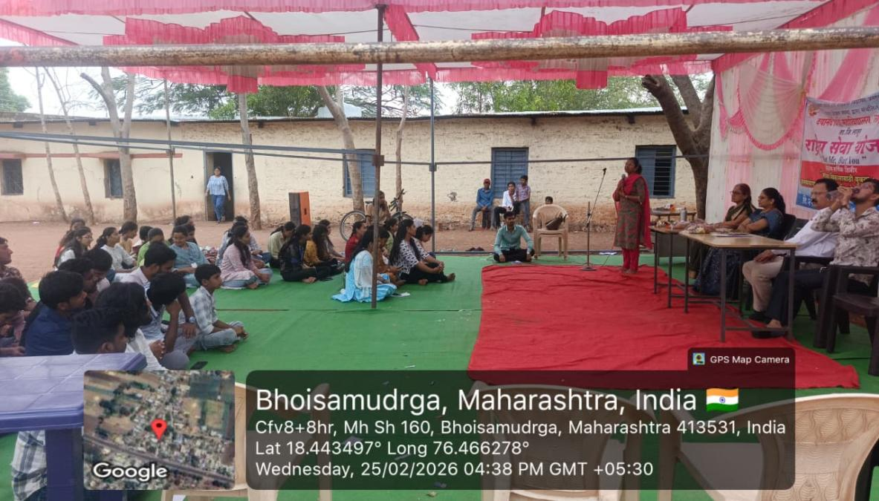
Asst. Prof. Shraddha Choudhary providing guidance to the volunteers in the programme “New and Diverse Opportunities in the Field of Law” (Date - 25.02.2026).
In the evening session, a “Legal Awareness Camp” was organized for the villagers. During this camp, the college students presented street plays on important issues such as child marriage and dowry deaths. They also provided information to the villagers about laws related to domestic violence, protection of senior citizens, and other socially beneficial legislations. The camp received support from Dr. Shubhangi Panchal and Prof. Ravindra Shetty.
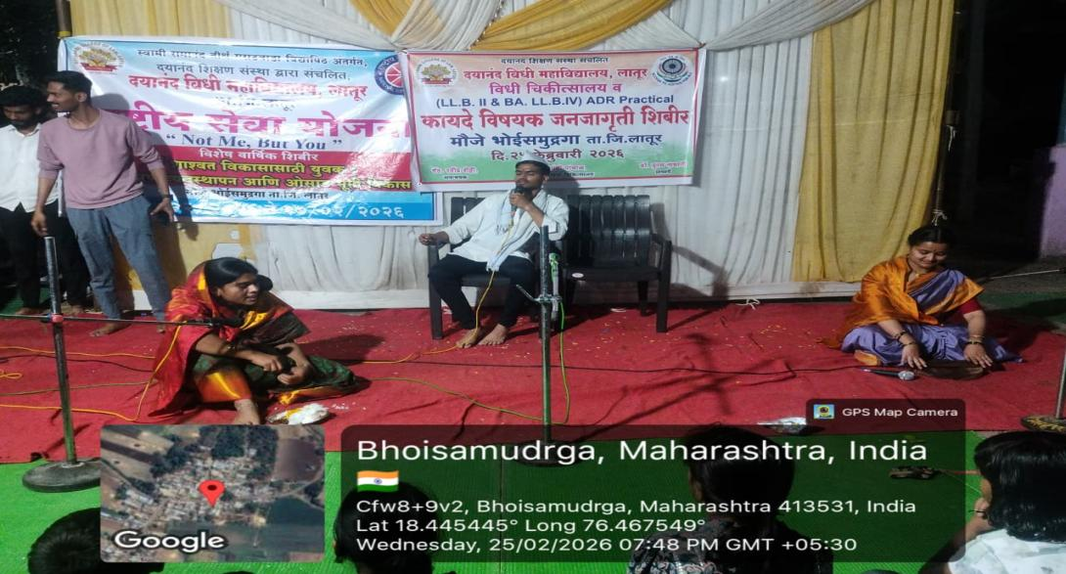
The volunteers presenting a Squit on ‘Child Marriage’ at Mauje Bhoisamudraga during the Camp (Date - 25.02.2026).

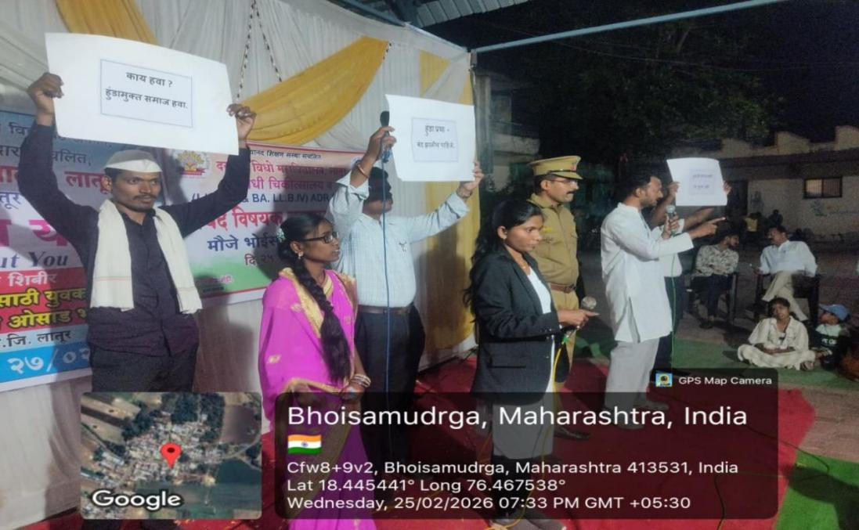
The volunteers presenting a Squit on ‘Dowry Death’ at Mauje Bhoisamudraga during the Camp (Date - 25.02.2026).

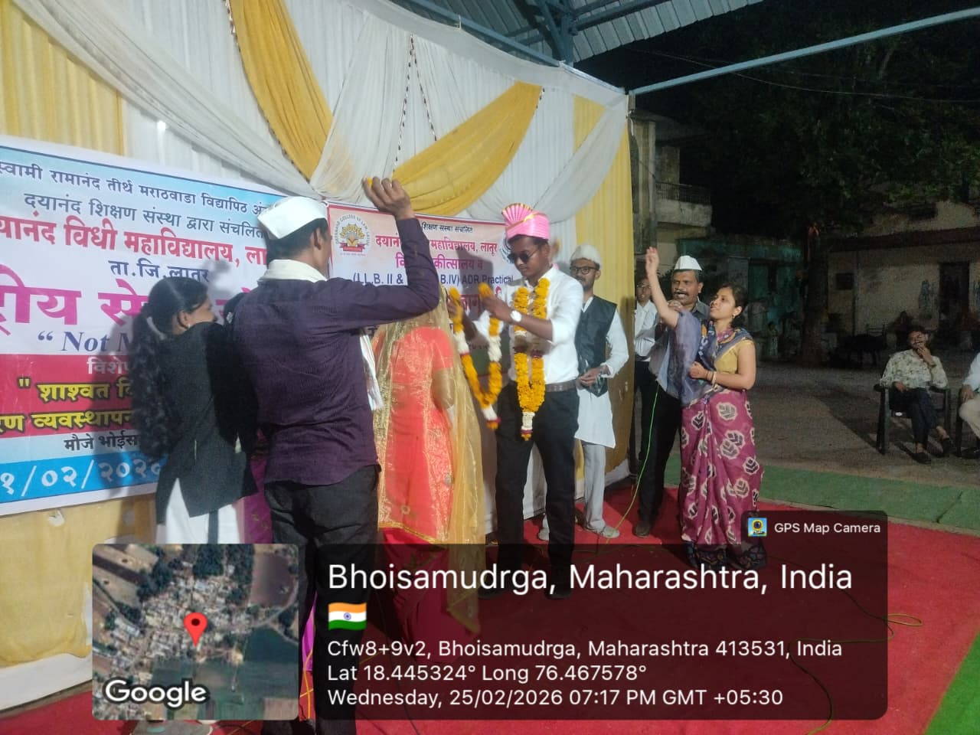
The volunteers presenting a Squit on ‘Child Marriage’ at Mauje Bhoisamudraga during the Camp (Date - 25.02.2026).
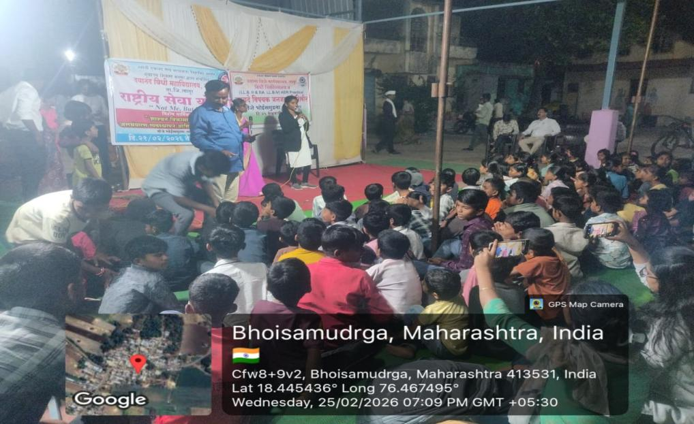
The volunteers presenting a Squit on ‘Child Marriage’ at Mauje Bhoisamudraga during the Camp (Date - 25.02.2026).
On the Sixth Day of the Camp (Date - 26.02.2026), in the morning session, to spread voting literacy among the villagers of Bhoisamudraga a “Voting Awareness Programme” was organized. Sau. Mangal Waghmare, Asha Volunteer, Ideal Woman Farmer prize winner and businesswoman from the village was invited to grace the occasion. During her address, she guided on significance of voting, addition and correction of names in the electoral list and other related matters. Later, as a part of “Shivar Pheri” the volunteers visited to the organic farm of hers and took information about organic farming, manufacturing and processing of milk products and other agri-related micro-businesses.
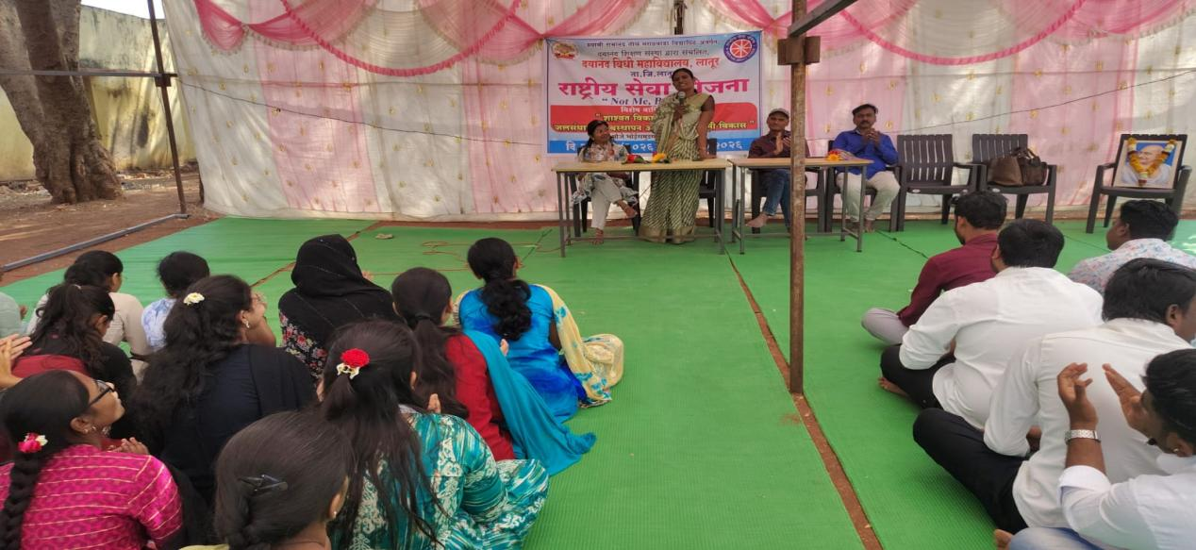
Mrs. Mangal Waghmare, Asha Volunteer, Ideal Woman Farmer prize winner and businesswoman addressing the participants in the programme on ‘Voting Awareness’. (Date - 26.02.2026).
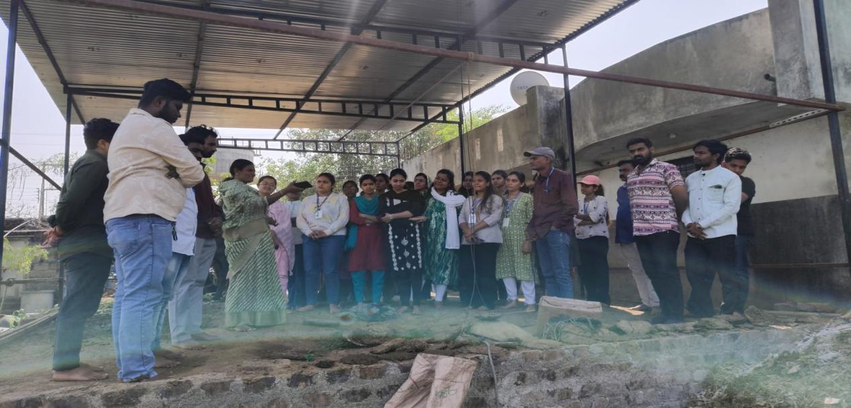
The volunteers receiving information of the ‘Cow-Dung Gas’ during the visit to the farm of Mrs. Mangal Waghmare (Date - 26.02.2026).
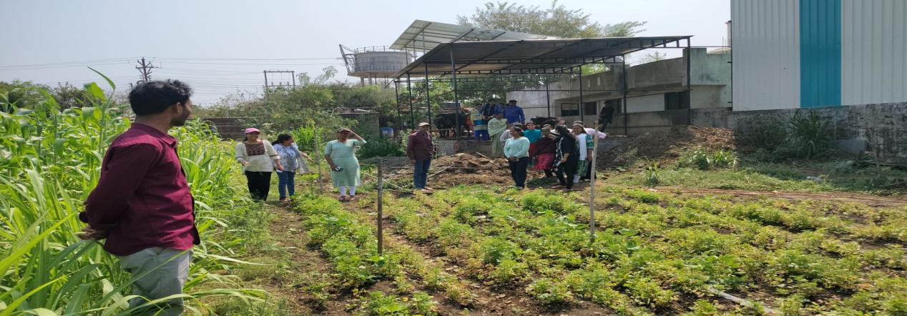
The volunteers receiving information of the organic farming during the visit to the farm of Mrs. Mangal Waghmare (Date - 26.02.2026).
In the evening session, a programme on “Human Rights Awareness” was organised in the village of Bhoisamudraga. In this programme, Dr. Gopal Panchal, Coordinator, Human Rights Education Centre, Dayanand College of Law, Latur highlighted the meaning and importance of human rights, its protection, the machinery of National and State Human Rights Commission, various human rights abuse cases, role of judiciary in the protection and promotion of human rights in India. With the help of current human rights issues, he gave a very good insight to all the participants. This programme was participated by the villagers, volunteers, Programme Officers.
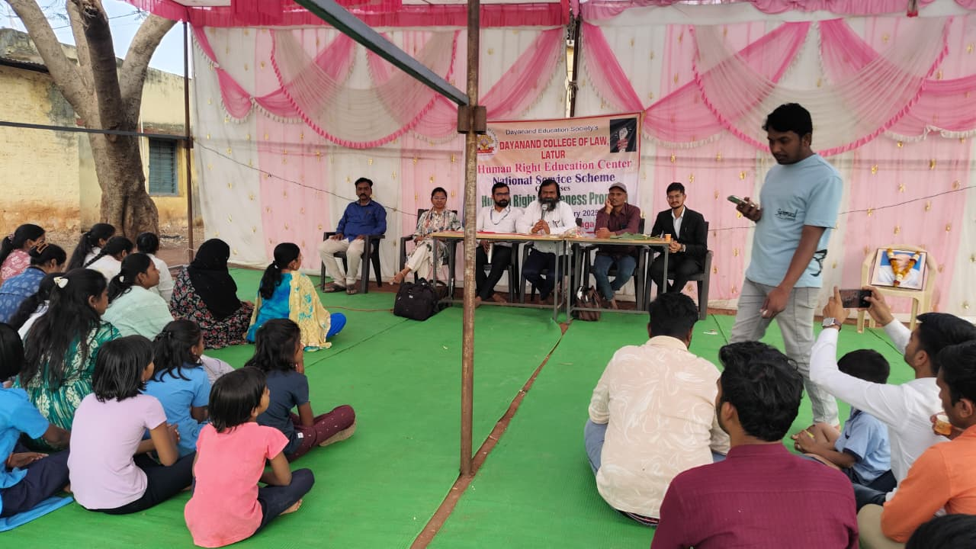
Dr. Gopal Panchal, Coordinator, Human Rights Education Centre guding the participants in the programme on ‘Human Rights Awareness’ (Date - 26.02.2026).
On the Seventh and last day of the Camp (Date - 27.02.2026), the valedictory ceremony of the seven-day annual special camp was organized at Mauje Bhoisamudraga.
On this occasion, Shri Hanumantraoji Gaikwad, the Chairperson, social worker and respected citizen of Mauje Bhoisamudraga, guided the volunteers and stated that the experiences gained during this seven-day camp would be valuable throughout their lives. He further emphasized that such camps help inculcate important qualities in students such as punctuality, discipline, teamwork, honesty, and a spirit of social service.
This program was graced by the presence of Shri Navnathji Mane, Headmaster of the Zilla Parishad Marathi School, Bhoisamudraga, Patel Madam, Programme Officer Prof. Umesh Katekar, Prof. Atish Tiwari, Prof. Sheetal Ghute, Vikas Mane, volunteers, and villagers.
This seven-day camp was organized under the guidance of the Principal of the college, Dr. Poonam Nathani. Various activities were conducted during the camp, including a free veterinary camp, health check-up camp, social awareness kirtan, village cleanliness drive, intellectual lectures on important topics, a human rights awareness workshop, powada performances, legal awareness programs, street plays, tree plantation, and several other activities. All these programs witnessed active participation from a large number of villagers.
At the end of the program, Programme Officers Prof. Umesh Katekar and Prof. Atish Tiwari expressed their gratitude to Shri Baliramji Salunke, the Zilla Parishad School, and the villagers for their valuable support in making the camp a success.
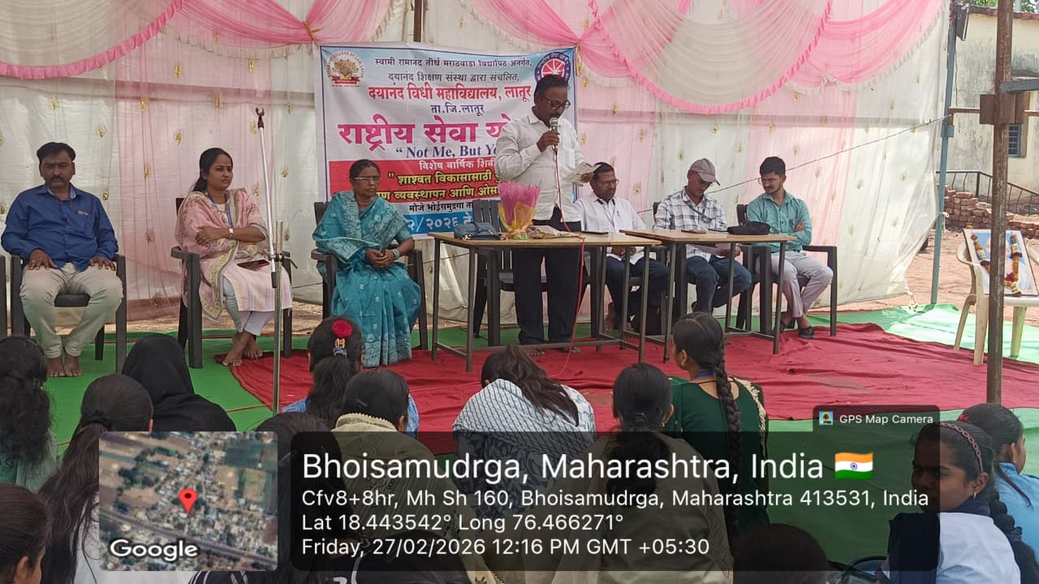
Shri Hanumantraoji Gaikwad, the Chairperson of the programme guiding the participants at the valedictory ceremony of seven day Special Annual Camp, NSS at Bhoisamudraga (Date - 27.02.2026).
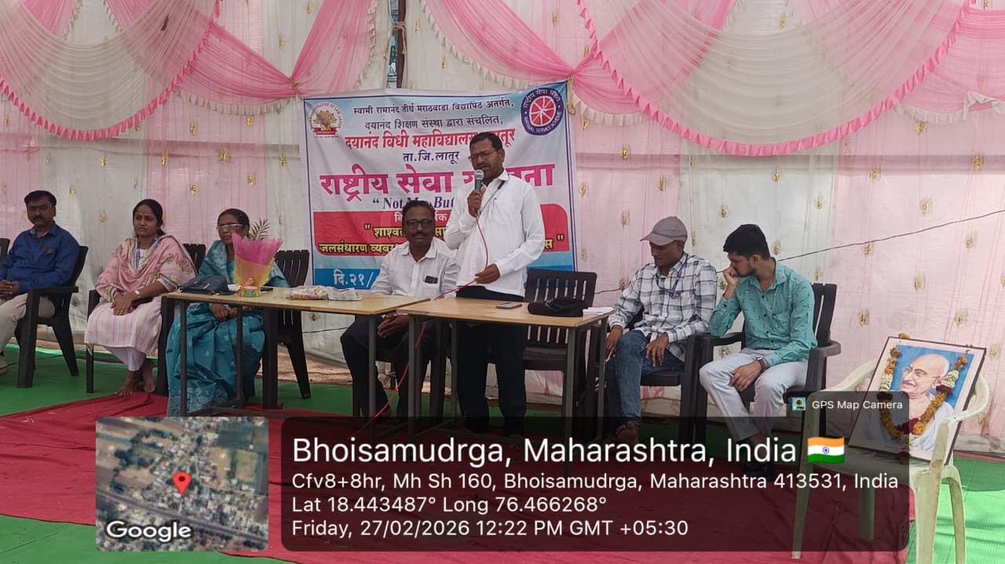
Shri Navnathji Mane, Headmaster of the Zilla Parishad Marathi School, Bhoisamudraga addressing the participants at the valedictory ceremony of seven day Special Annual Camp, NSS at Bhoisamudraga (Date - 27.02.2026).

On the occasion of the valedictory ceremony, tree plantation was carried out in the premises of the Zilla Parishad School, and Tulsi saplings were distributed among the villagers.
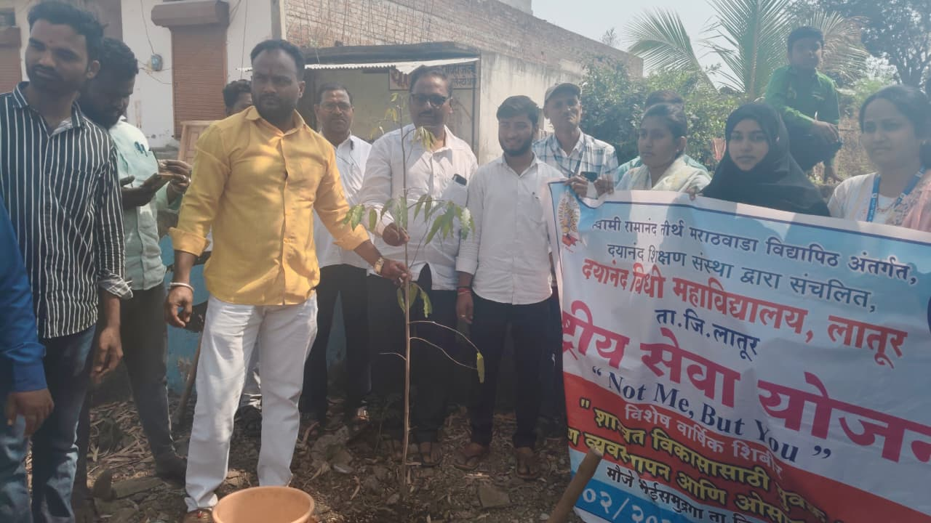
Tree Plantation at the valedictory session of the NSS Camp at Bhoisamudraga (Date - 21.02.2026).
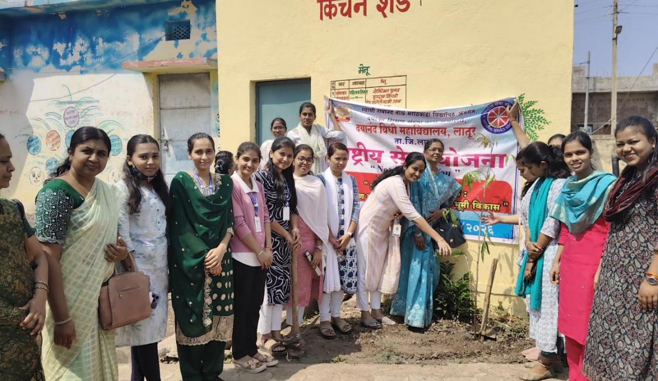
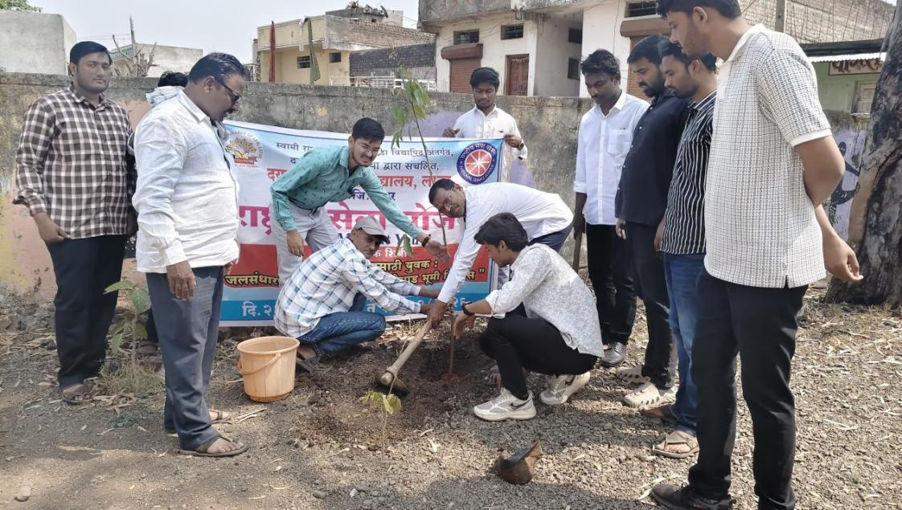
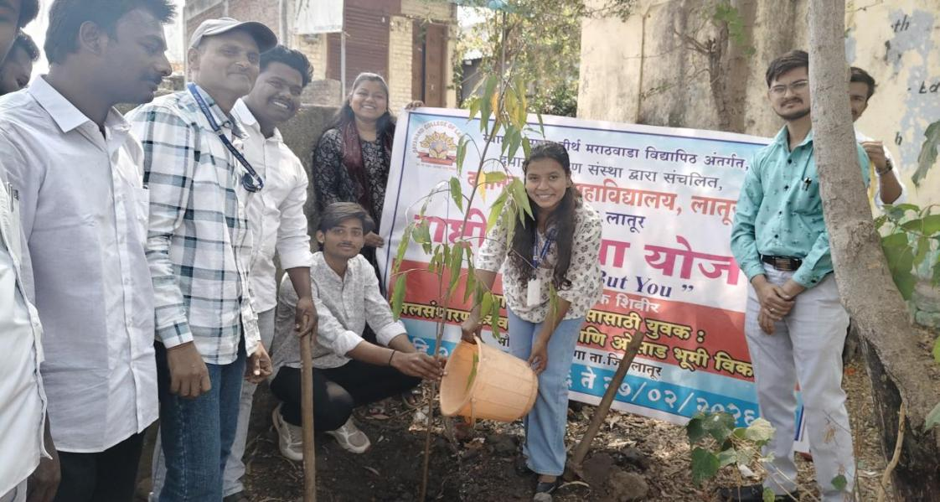
Tree Plantation at the valedictory session of the NSS Camp at Bhoisamudraga (Date - 21.02.2026).
- Celebration of Birth Anniversary of Yashwantrao Chavan (Date - 12.03.2026)
On 12.03.2026, the NSS Unit celebrated the birth anniversary of first Chief Minister of State of Maharashtra Late Yashwantrao Chavan. He was an Indian freedom fighter and politician who served as 8th Minister of Finance from 1970 to 1971 and 1971 to 1974. He served as the last Chief Minister of Bombay State and the first of Maharashtra after latter was created by the division of Bombay state.
During this programme, Mr. Suraj Somvanshi shared the information about the life story of Yashwantrao including his childhood, education and his works in the social service, freedom fighting and politics.
Dr. P.P. Nathani, Principal, and the members from teaching and non-teaching staff were present at this occasion. This programme was anchored by Amit Kathar and Asst. Prof. Atish Tiwari, Asst. Programme Officer proposed vote of thanks.

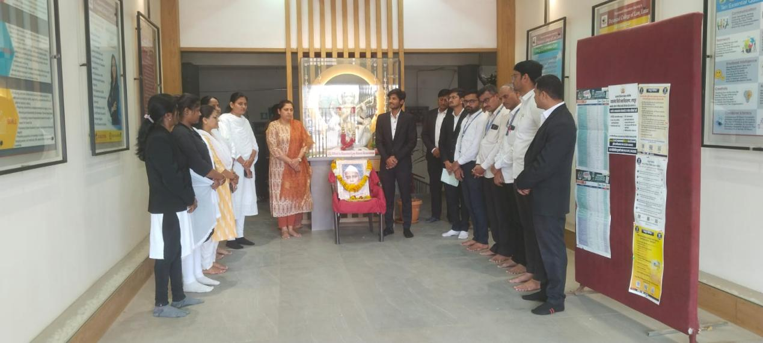

Celebration of birth anniversary of Yashwantrao Chavan , the first Chief Minister of State of Maharashtra at Dayanand College of Law, Latur (Date - 12.03.2026).

- Celebration of Birth Anniversary of Mahatma Phule (Date - 11.04.2026) -
On 11 April 2026, NSS, Dayanand College of Law, Latur celebrated the Birth Anniversary of Mahatma Jyotiba Phule in the College. He was a great social reformer, thinker, educationalist, and pioneer of social justice who worked tirelessly for the upliftment of women and the oppressed sections of society.

At the outset, Dr. Poonam P. Nathani, Principal, Dayanand College of Law, offered a floral tribute to the portrait of Mahatma Jyotiba Phule. The staff members also paid their homage with great respect and gratitude.
Later, Asst. Prof. Anil Gaikwad shared valuable information regarding the life, social reforms, educational contributions, and revolutionary work of Mahatma Jyotiba Phule, highlighting his efforts in promoting education for all.
This programme was attended by the members of Teaching, Non-Teaching staff and students of the College. The programme was well-organized by Non-Teaching Staff Mr. Rakesh Tekale, whose contribution played an important role in the successful conduct of the event. Asst. Prof. Atish Tiwari, Asst. Programme Officer, NSS anchored this programme and proposed vote of thanks.

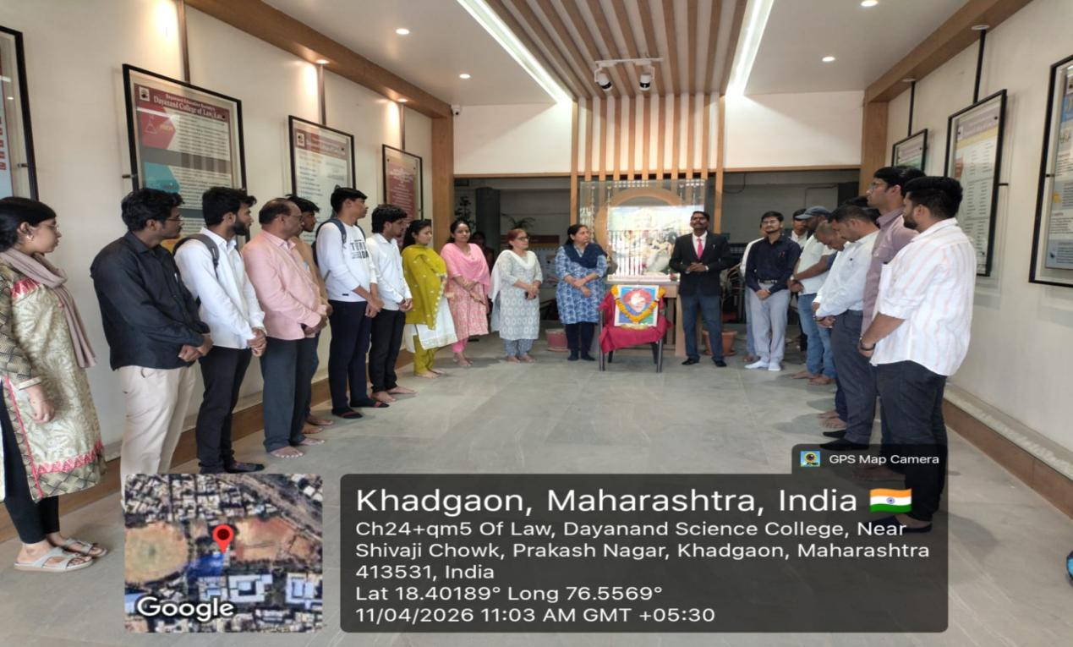

Asst. Prof. Anil Gaikwad sharing the information about the life-works of Mahatma Phule during the programme (Date - 11.04.2026).

- Celebration of Birth Anniversary of Dr. Ambedkar (Date - 14.04.2026) -
On 14.04.2026, NSS, Dayanand College of Law, Latur celebrated the Birth Anniversary of Bharat Ratna Dr. B. R. Ambedkar in the College. He was a great jurist, economist, social reformer, and the architect of the Indian Constitution who devoted his life to equality, justice, and human dignity.

At the beginning of the programme, Dr. N.D. Jadhav, Career Guidance Cell.offered floral tribute to the portrait of Bharat Ratna Dr. Babasaheb Ambedkar. All the staff members also paid their respectful homage and remembered his invaluable contributions.
On this occasion, the Programme Officer Prof. Umesh Katekar shared important information about the life and work of Dr. B. R. Ambedkar. Special emphasis was given to his contribution in the legal field, where he handled various important cases and worked strongly for justice, rights, and equality. His role as a legal expert and his efforts to protect the rights of the weaker sections of society were clearly explained.

The programme was attended by the Teaching, Non-Teaching staff members & Students of the College. This programme was anchored by and vote of thanks was proposed by Asst. Prof. Atish Tiwari, Asst. Programme Officer. The preparation of the programme were carried out by Suraj Birajdar.

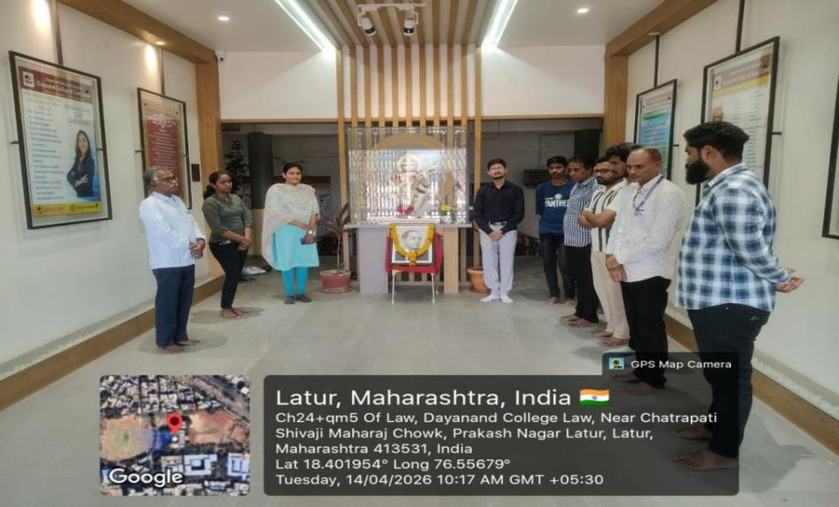

Celebration of Birth Anniversary of Dr. Babasaheb Ambedkar at Dayanand College of Law, Latur (Date - 14.04.2026).

- Celebration of Birth Anniversary of Rashtrasant Tukdoji Maharaj (Date - 30.04.2026) -
On the occasion of the Birth Anniversary of Rashtrasant Tukdoji Maharaj, NSS, Dayanand College of Law, Latur organized a programme in the College to pay tribute to the great saint, social reformer, and spiritual leader who devoted his life to social awareness, national unity, and rural development.
At the beginning of the programme, Dr. Poonam Nathani, Principal, offered floral tribute to the portrait of Rashtrasant Tukdoji Maharaj. The Teaching and Non-Teaching staff members also paid respectful homage on the occasion.
On this occasion, Assistant Professor Omprakash Jadhav shared valuable information regarding the life, teachings, social work, and contribution of Rashtrasant Tukdoji Maharaj towards society and nation-building. He explained the importance of humanity, discipline, rural development, and service to society through the teachings of the great saint.
The programme was smoothly conducted by Atish Tiwari, Co-Programme Officer of the National Service Scheme (NSS). The programme was attended by the members of Teaching and Non-Teaching staff and students of the College.

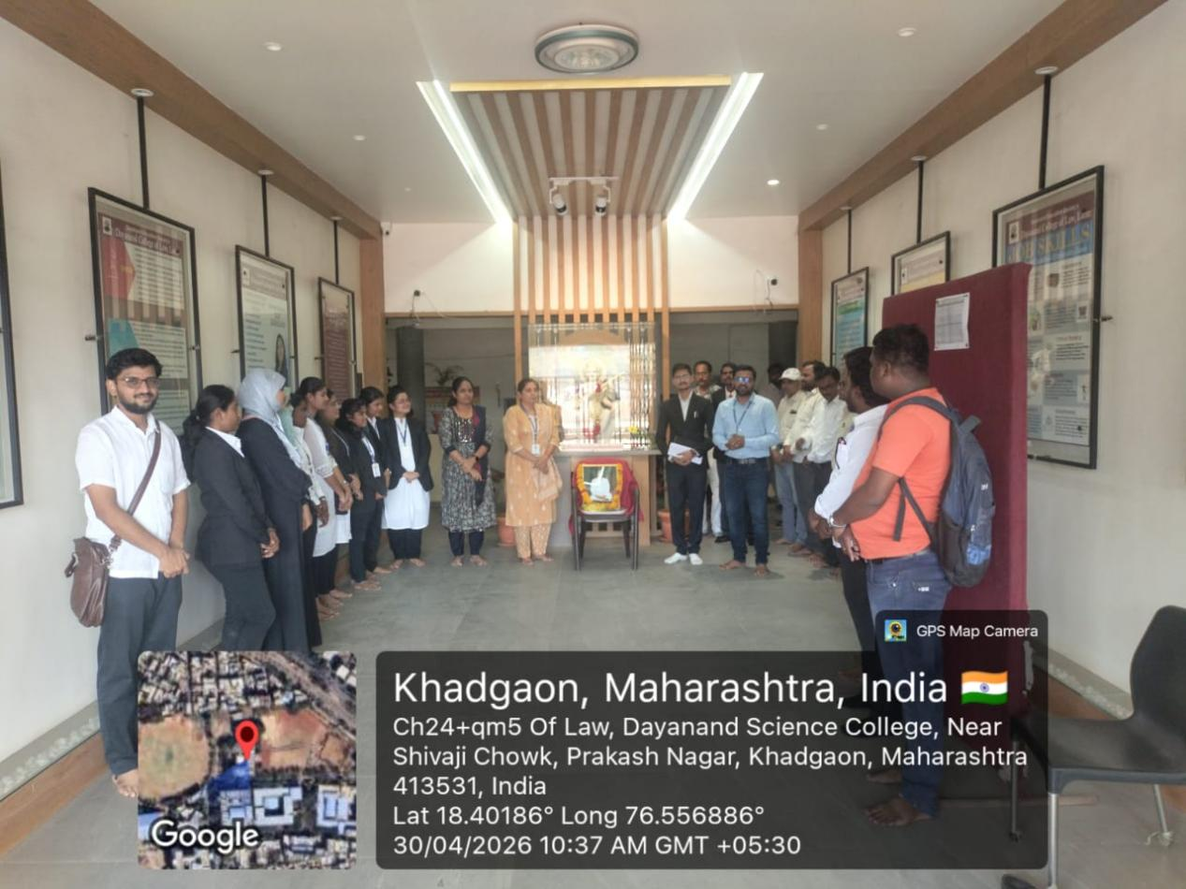
Asst. Prof. O.K. Jadhav sharing information on the lifestory of Rashtrasant Tukdoji Maharaj at the birth anniversary programme (Date - 30.04.2026).

